


UK Railroads Performance and Revenue Analysis

Analyzed and Prepared By: Abdel-Rahman Hassan
Ahmed Mahmoud Mohie Elmaasarawi

Under Supervision from: Eng. Ahmed Samir

Training Company: ILearn

Table of Contents
📘 Chapter 1: Introduction to Dataset 6
🗂 Overview 6
📄 Data Structure 6
📏 Data Dimensions 8
§ Tools and Methods 8
Rationale for Tool Selection 10
🧹 Chapter 2: Data Cleaning , Wrangling and normalization 10
I- Data Cleaning and Wrangling 11
🧰 Step 1: Importing Required Libraries 11
🎨 Step 2: Setting the Style for Plots 12
📥 Step 3: Loading the Dataset 12
🔍 Step 4: Previewing the First Few Rows of the Dataset 13
📊 Step 5: Checking the Dataset’s Structure and Data Types 14
🚨 Step 6: Checking for Missing Values in the Dataset 15
📋 Step 7: Generating Summary Statistics for the Dataset 16
🔢 Step 8: Checking Unique Values in Categorical Columns 17
🔄 Step 9: Standardizing Categorical Values 18
🔢 Step 10: Re-checking Unique Values in Categorical Columns after Replacement 19
🧼 Step 11: Handling Missing Values in Categorical Columns 20
🔢 Step 12: Re-checking Unique Values in Categorical Columns after Handling Missing Data 21
🧼 Step 13: Handling Missing Values in "Reason for Delay" Column 22
📅 Step 14: Converting "Date of Purchase" to DateTime Format 22
🔍 Step 15: Previewing the First Few Rows After Modifications 23
🕒 Step 16: Converting "Time of Purchase" to Time Format 24
🔍 Step 17: Previewing the First Few Rows After Time Transformation 25
🔎 Step 18: Checking for Trips Without Actual Arrival Time 26
🛤 Step 19: Creating a New Column for the Route 27
👀 Step 20: Previewing the New "Route" Column 28
📅 Step 21: Creating "Arrival DateTime" and "Actual Arrival DateTime" Columns 29
⏱ Step 22: Calculating the Delay in Minutes 30
🔍 Step 23: Previewing the First Few Rows After Delay Calculation 31
🚨 Step 24: Checking for Duplicate Entries Based on Key Columns 32
🔍 Step 25: Previewing the First Few Rows After Duplicate Check 33
📘 II- Data Normalization 34
⚠ Step 27: Identifying Conflicting Groups with Different "Journey Status" Values 34
🔄 Step 28: Preparing the Trips Table by Removing Duplicates 35
👀 Step 29: Previewing the "Trips" Table and generating a new unique column for the trip ID 36
🔗 Step 30: Merging "Trip ID" into the Original DataFrame 37
🔍 Step 31: Identifying Unique Departure and Arrival Stations 38
📍 Step 32: Combining Unique Departure and Arrival Stations 38
🗺 Step 33: Displaying the Combined List of Unique Stations 39
👀 Step 34: Previewing the Updated DataFrame 39
🛠 Step 35: Installing Geopy for Geospatial Operations 40
🌍 Step 36: Fetching Coordinates for Stations Using Geopy 41
🗺 Step 37: Previewing the Stations DataFrame with Coordinates 43
🏷 Step 38: Defining Station Name to ID Mapping 44
🏷 Step 39: Adding "Station ID" to the Stations DataFrame 46
👀 Step 40: Previewing the First 15 Rows of the Updated DataFrame 47
👀 Step 41: Previewing the First 15 Rows of the "Trips" DataFrame 48
🛤 Step 42: Extracting Unique Trip Combinations to create new routes table 49
🧮 Step 43: Getting the Number of Unique Routes 50
📅 Step 44: Converting 'Date of Journey' to Datetime Format 50
🗓 Step 45: Converting 'Date of Journey' to Datetime Format in the df DataFrame 51
🗓 46: Defining a Function to Classify Days as Weekday or Weekend 51
🏷 Step 47: Applying the is_weekday Function to Classify Days 52
🏷 48: Classifying Days in the df DataFrame 52
👀 Step 49: Previewing the "Trips" DataFrame 53
Step 50: Reverse Engineering to obtain original price of tickets before discounts 54
Step 51: Calculating the discounted amount (revenue loss) 56
Step 52: Trip time segmentation – Part 2 57
Step 53: Application of previous functions 58
💾 Step 54: Saving the df_stations DataFrame to a CSV File 58
💾 Step 55: Saving the df DataFrame to a CSV File 59
💾 Step 56: Saving the trips DataFrame to a CSV File 59
💾 Step 57: Saving the routes DataFrame to a CSV File 60
III – Data Augmentation: 61
Step 1 : Adding Distance column 61
Step 2: Adding Price/100Kilometer column: 62
Chapter 3: Exploratory Data Analysis of Analysis Questions 62
Step1: Assessing the overall punctuality of journeys 62
Step2: Discovering the most common reasons of delays and cancellations 63
Step 3: Discovering routes with the highest number of delays and cancellations 65
Step 4: Analyzing reasons for delays per route 67
Step 5: Visualizing Assessing reasons for delay in routes 70
Step 6: Analyzing disruptions by hour of the day 73
Step 7: Arrival Destinations vs Departure stations Delays 79
Step 8: Effect of day type on disruption 80
Step 9: Analysing routes with highest delayed and cancellations rate 81
Step 10: Analyze delay reasons for 100% disrupted routes 83
Step 11: Discounts system and pricing strategy 84
Step 11: Analysis Report: Refund Requests by Journey Status: 87
Step 12: Purchase Day Trends Analysis Report 88
Step 13- Effect of Card type of price: 89
Step 14: Initial Revenue by Route: 91
Step 15: Analyzing the amount of refunds for each reason for delay 93
Step 16: Analysis of the root causes of interruptions (Top Factors Affecting Punctuality) 94
Step17: Analyzing Departure stations: 95
Step 18: Pricing and Discounts Analysis 97
Step 19: Price Elasticity Analysis 100
Chapter 4: Predictions Based of Alteration of Discount Percentage of Advance tickets 103
Chapter 5: Data Visualization Utilizing tableau 105
Dashboard 1: Overview 105
Dashboard 2: Sales and Passengers Analysis 108
Dashboard 3: Latency and Cancellations Analysis 109
Dashboard 4: Pricing and Discounts Policy 114
Chapter 6: Executive Summary and Recommendations 117
I. Critical Disruption Insights 117
II. Priority Actions and Strategic Recommendations 118
III. Revenue Optimization & Customer Experience 119
📌 Conclusion 120

📊 UK Railway Data Analytics Project

📘 Chapter 1: Introduction to Dataset
This project focuses on analyzing real-world UK railway data to explore customer behavior, service efficiency, and operational performance. The dataset under analysis includes thousands of ticket transactions and journey records, providing a rich foundation for insights.
In this chapter, we begin by understanding the structure and nature of the data. A clear understanding of the dataset and its variables is essential before performing any data cleaning, transformation, or modeling steps.

🗂 Overview
This dataset contains 31,653 records detailing train journeys, ticket purchases, and performance metrics within the UK rail system. The goal is to analyze customer purchasing behavior, travel patterns, punctuality of train services, and refund activity.
Each record represents a single train ticket transaction, capturing everything from the purchase method and ticket type to journey timing and any potential delays.

📄 Data Structure
The dataset includes 18 columns, each offering valuable insights into the customer journey and service performance. Below is a detailed explanation of each field:

Column Name | Description
Transaction ID | Unique identifier for each train ticket purchase.
Date of Purchase | The calendar date when the ticket was purchased.
Time of Purchase | The specific time when the purchase was made.
Purchase Type | How the ticket was purchased — either Online or at a Station.
Payment Method | Payment method used, such as Contactless, Credit Card, Debit Card.
Railcard | Indicates if a railcard was used (Adult, Senior, or Disabled), or None. ⅓ OFF
Ticket Class | Class of ticket purchased, commonly Standard or First Class.
Ticket Type | Type of ticket Advance ½ OFF - Off-Peak ¼ OFF - Anytime full price
Price | Cost of the ticket in GBP (£)
Departure Station | Name of the station where the journey begins.
Arrival Destination | Final destination station for the journey.
Date of Journey | The date the train journey was scheduled to occur.
Departure Time | Scheduled departure time from the starting station.
Arrival Time | Scheduled arrival time at the destination.
Actual Arrival Time | Actual time train arrived at the destination.
Journey Status | Whether the journey was On Time, Delayed, or Cancelled.
Reason for Delay | If delayed, the reason provided (e.g., Signal Failure).
Refund Request | Indicates whether the passenger submitted a refund request (Yes/No).

📏 Data Dimensions
- Rows: 31,653

- Columns: 18

- Primary Key: Transaction ID

§ Tools and Methods
To conduct this analysis, we leveraged a combination of modern data tools and methodologies to ensure robust data processing, accurate analysis, and actionable insights:

1. Python
- Primary Use: Data cleaning, wrangling, and normalization.
- Key Tasks:
Performed ETL (Extract, Transform, Load) operations to handle missing values, outliers, and inconsistencies.
Engineered features (e.g., calculated price per 100km, derived customer segments) to support modeling.
Implemented statistical normalization (e.g., StandardScaler) for machine learning readiness.
Assisted preliminary visualization before finalizing in Tableau (e.g., exploratory plots via matplotlib/seaborn).
Libraries: Pandas, NumPy, Scikit-learn, SciPy.

2. SQL
- Primary Use: Answering business-critical analysis questions.
- Key Tasks:
Aggregated transactional data to analyze demand patterns by route, time, and customer type.
Joined tables to consolidate features (e.g., merging ticket sales with route details).
Optimized queries for performance on large datasets.

3. Web Scraping
- Primary Use: Augmenting data with real-world metrics.
- Key Tasks:
  - Extracted station-to-station distances via Google Maps.

4. Excel
- Limited Use: Manual adjustments and quick validations.
- Key Tasks:
  - Added auxiliary columns (e.g., distances between stations).
  - Served as a cross-check tool for small-scale data verification.

5. Tableau
- Primary Use: Visualization and stakeholder reporting.
- Key Tasks:
  - Developed interactive dashboards to highlight pricing trends, demand hotspots, and model outputs.
  - Created geospatial maps to visualize route performance.

Rationale for Tool Selection
- Python: Chosen for its flexibility in handling complex data transformations and modeling.
- SQL: Essential for efficient querying of relational databases.
- Web Scraping: Enabled data enrichment where internal records were incomplete.
- Excel+Tableau: Balanced quick edits (Excel) with scalable, shareable visuals (Tableau).
This multi-tool approach ensured both technical rigor (Python/SQL) and accessibility (Tableau/Excel) for stakeholders.

🧹 Chapter 2: Data Cleaning , Wrangling and normalization

Data Cleaning and Wrangling

🧰 Step 1: Importing Required Libraries

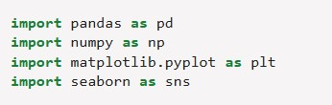
Why?
These are the core Python libraries used for data manipulation (pandas, numpy) and visualization (matplotlib, seaborn).
- pandas is used for handling and analyzing data in tabular form (DataFrames).

- numpy is used for numerical operations and managing arrays.

- matplotlib.pyplot and seaborn are used for creating various types of plots and visualizations, such as histograms, scatter plots, and correlation matrices.

🎨 Step 2: Setting the Style for Plots

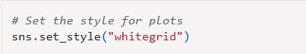
Why?
This line of code sets the visual style of the plots using Seaborn.
- sns.set_style("whitegrid") applies the "whitegrid" style, which makes the background of the plot white with gridlines.
- This style enhances the readability of plots, especially when dealing with numeric data, by adding gridlines to the background while maintaining a clean aesthetic.
By using set_style(), you ensure that all subsequent visualizations follow a consistent and polished design.

📥 Step 3: Loading the Dataset
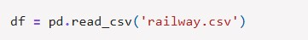
Why?
This line of code loads the dataset from a CSV file into a Pandas DataFrame.
- pd.read_csv('railway.csv') is a function in Pandas that reads the data from the specified CSV file (railway.csv) and stores it in a DataFrame (df).

- A DataFrame is a two-dimensional, size-mutable, and potentially heterogeneous tabular data structure with labeled axes (rows and columns), which makes it ideal for analyzing and manipulating structured data.
This is a critical step as it imports the dataset into the working environment, allowing you to start analyzing and processing the data.

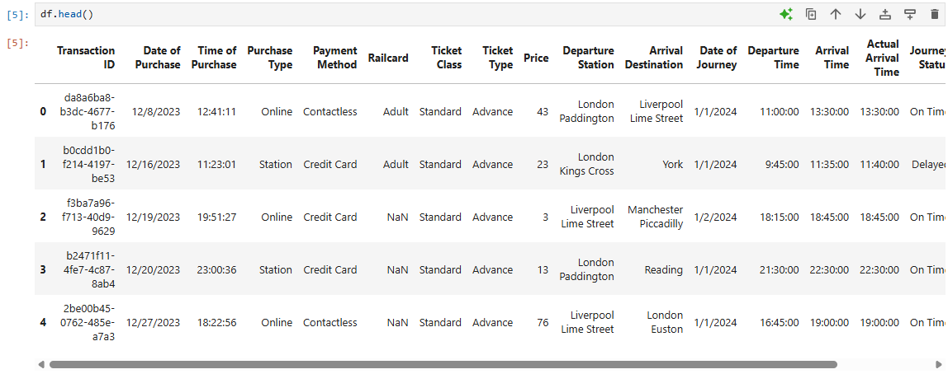
🔍 Step 4: Previewing the First Few Rows of the Dataset

Why?
This line of code displays the first 5 rows of the dataset.
- df.head() is a convenient method in Pandas that helps to quickly check the structure of the dataset and get an overview of the data.

- This is useful for understanding the format of the data, identifying column names, and getting a quick glimpse of the data types and values in the first few rows.

By inspecting the first few rows, you can quickly verify that the data has been loaded correctly and check if any immediate issues need to be addressed.

📊 Step 5: Checking the Dataset’s Structure and Data Types
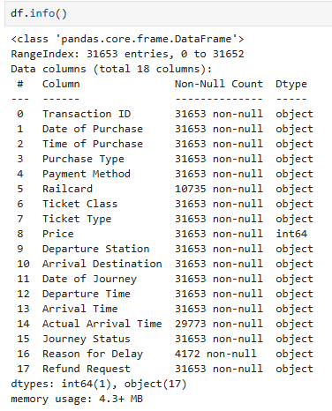
Why?
This line of code provides a concise summary of the dataset’s structure.
- df.info() displays key information about the DataFrame, such as the number of non-null entries, data types of each column, and memory usage.

- This is useful for identifying columns with missing values, understanding the data types (e.g., numerical, categorical), and gaining insights into the dataset’s overall structure.

By running this method, you can assess whether further data cleaning steps are necessary, such as handling missing values or converting data types.

🚨 Step 6: Checking for Missing Values in the Dataset
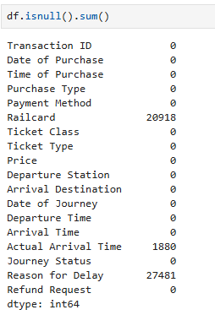
Why?
This line of code helps to identify missing or null values in the dataset.
- df.isnull() returns a DataFrame of the same shape as df, with True values indicating missing data (nulls) and False values otherwise.

- .sum() aggregates the True values in each column, giving the total count of missing values per column.

This is an important step in data cleaning as missing values can affect analysis, and this output helps you determine how to handle them (e.g., by imputing, dropping, or replacing them).
The results showed that three variables contained null values; Railcard (indicating no card was used), Actual arrival time (because trips were cancelled) and reason for delay (because trips were not delayed nor cancelled).

📋 Step 7: Generating Summary Statistics for the Dataset
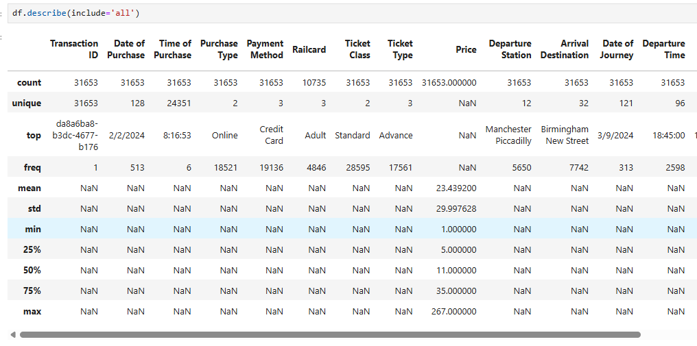
Why?
This line of code provides summary statistics for the dataset, including both numerical and categorical columns.
- df.describe(include='all') generates descriptive statistics like mean, standard deviation, minimum, maximum, and percentiles for numerical columns. When include='all' is specified, it also includes summary statistics for categorical columns
(such as count, unique values, top value, and frequency).

- This is useful for getting an overall understanding of the dataset, including the distribution of numerical features and the frequency of categories in categorical features.

This step helps you detect outliers, understand data distribution, and quickly assess whether the data meets any assumptions for further analysis.

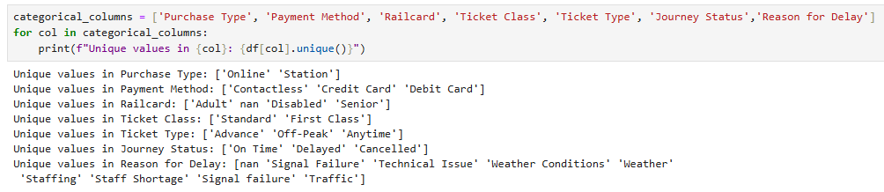
🔢 Step 8: Checking Unique Values in Categorical Columns

Why?
This block of code checks and prints the unique values in a list of categorical columns.
- categorical_columns is a list containing the names of columns that are likely to have categorical data (non-numeric or text data).

- The for loop iterates through each column in categorical_columns, and df[col].unique() returns the unique values in each column.

- This is useful for understanding the distinct categories or labels present in the dataset, which is critical for tasks like encoding categorical variables or identifying data inconsistencies.
By inspecting the unique values, you can also spot any inconsistencies in the categorical data, such as typos, duplicates, or unexpected categories.
Some inconsistencies are observed in Reason for delay.

🔄 Step 9: Standardizing Categorical Values
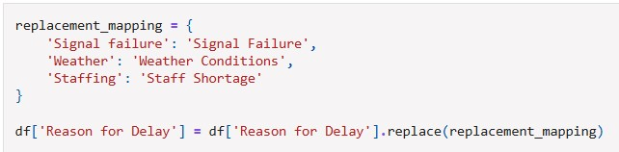
Why?
This code block standardizes the categorical values in the "Reason for Delay" column by replacing inconsistent or misformatted entries with a standardized version.
- replacement_mapping is a dictionary where the keys represent the original values and the values are the desired replacements.

- df['Reason for Delay'].replace(replacement_mapping) replaces any occurrences of the specified keys with the corresponding values in the DataFrame.
This step helps to clean and standardize the dataset by ensuring that categorical values are consistent, which is crucial for accurate analysis and modeling. It also reduces errors caused by inconsistent data entries (like capitalization or phrasing differences).


🔢 Step 10: Re-checking Unique Values in Categorical Columns after Replacement

Why?
This block of code checks and prints the unique values in the categorical columns after any changes or replacements have been made (such as standardizing entries in the "Reason for Delay" column).
- After performing data cleaning tasks like replacing values, it's essential to re-check the unique values to verify that the updates were applied correctly.

- The for loop iterates through each categorical column, and df[col].unique() returns the unique values in each column, providing insight into the new set of categories.
This step ensures that the replacements and any data cleaning steps have worked as expected, and it helps to identify any remaining inconsistencies or outliers in categorical data.

🧼 Step 11: Handling Missing Values in Categorical Columns
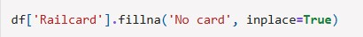
Why?
This line of code handles missing (null) values in the "Railcard" column by filling them with a default value.
- df['Railcard'].fillna('No card', inplace=True) fills any missing or NaN values in the "Railcard" column with the string 'No card'.

- The inplace=True argument modifies the original DataFrame, meaning the missing values are directly replaced without needing to assign the result to a new variable.

This step is important because handling missing data is crucial for ensuring accurate analysis and preventing errors during modeling. In this case, replacing missing values with 'No card' makes sense for a categorical variable where the absence of a railcard can be treated as a specific category.

🔢 Step 12: Re-checking Unique Values in Categorical Columns after Handling Missing Data
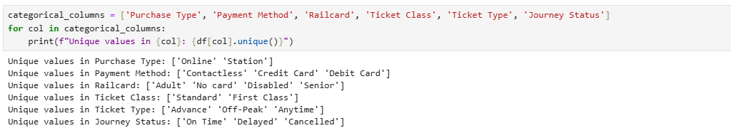
Why?
This code block is used to verify the unique values in the categorical columns after handling missing data (such as filling in missing values for the "Railcard" column).
- After filling in missing values (e.g., for "Railcard"), it's good practice to re-check the unique values to ensure the changes were applied correctly.

- The for loop iterates through each column in categorical_columns and prints the unique values in those columns using df[col].unique().

This step helps ensure that the data is cleaned and formatted correctly, and provides a quick way to spot any unexpected values that might still remain after the cleaning process.

🧼 Step 13: Handling Missing Values in "Reason for Delay" Column
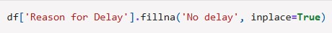
Why?
This line of code fills any missing (null) values in the "Reason for Delay" column with a default value of 'No delay'.
- df['Reason for Delay'].fillna('No delay', inplace=True) replaces any
NaN values in the "Reason for Delay" column with the string 'No delay'.

- The inplace=True argument modifies the original DataFrame, ensuring that the missing values are directly replaced in place, without needing to create a new DataFrame.
This step ensures that missing entries in the "Reason for Delay" column are appropriately handled by assigning a sensible default value, which is crucial for consistent data analysis, especially when dealing with categorical variables.

📅 Step 14: Converting "Date of Purchase" to DateTime Format
Why?
This line of code converts the "Date of Purchase" column from a string or object format into a proper datetime format.
- pd.to_datetime(df['Date of Purchase'], dayfirst=False) parses the
values in the "Date of Purchase" column and converts them into datetime objects that are easier to work with for time-based analysis.

- The dayfirst=False argument specifies that the date format follows the
"MM/DD/YYYY" convention (month first), which is common in many regions, but can be adjusted to True if the date format is day-first (DD/MM/YYYY).

This step is essential for proper date handling and manipulation, allowing you to perform time-based operations such as filtering, sorting, and extracting date components (like year, month, or day).

🔍 Step 15: Previewing the First Few Rows After Modifications
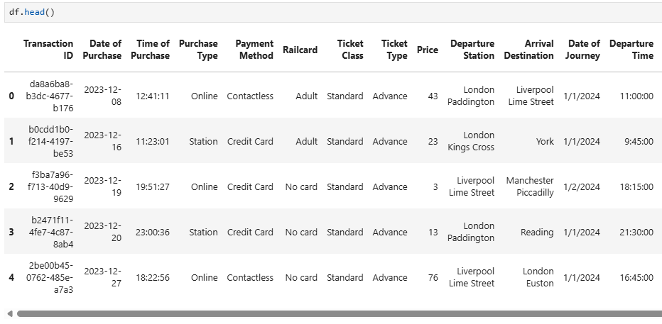
Why?
This line of code displays the first 5 rows of the dataset after all the modifications (such as handling missing values and converting the "Date of Purchase" column).
- df.head() provides a snapshot of the dataset, showing how the data looks after the cleaning and transformation steps have been applied.

- This is useful for verifying that the changes were implemented correctly, allowing you to confirm that missing values were filled, date columns were converted, and other transformations were successful.
By previewing the data again, you can ensure that everything is in order before proceeding with further analysis or modeling.

🕒 Step 16: Converting "Time of Purchase" to Time Format
Why?
This line of code converts the "Time of Purchase" column from a string or object format into a time format, retaining only the time portion of the datetime.
- pd.to_datetime(df['Time of Purchase']) converts the "Time of Purchase" column into a datetime object.
- .dt.time extracts just the time component (hours, minutes, seconds) from the datetime object, discarding the date part.
This step is useful for working with the time data separately, for example, when analyzing purchase patterns or trends based on the time of day.

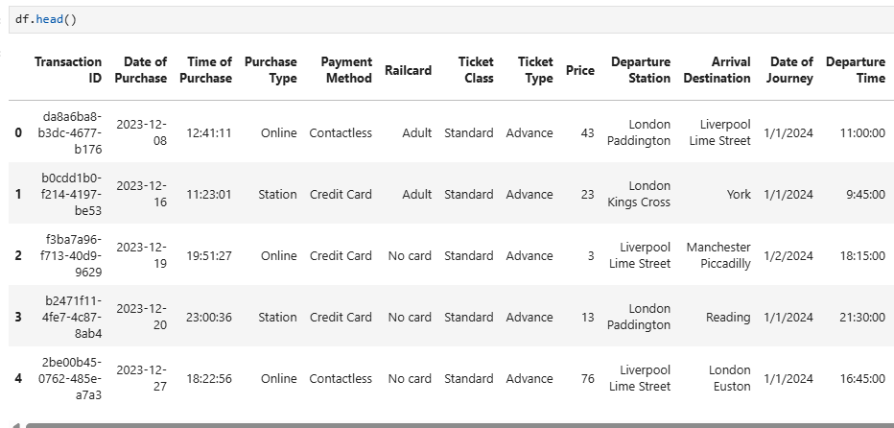
🔍 Step 17: Previewing the First Few Rows After Time Transformation
Why?
This line of code displays the first 5 rows of the dataset after the transformation of the "Time of Purchase" column into a time format.
- df.head() provides a quick look at the dataset, allowing you to verify that the changes made to the "Time of Purchase" column were successfully applied.

- It ensures that the time portion is correctly extracted and formatted, and helps in confirming that no unintended modifications have occurred.

By previewing the data again, you can ensure that all previous data processing steps have been correctly executed before moving forward with further analysis.

🔎 Step 18: Checking for Trips Without Actual Arrival Time
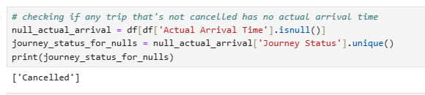

Why?
This block of code identifies any trips that do not have an "Actual Arrival Time" and checks their corresponding "Journey Status".
- df[df['Actual Arrival Time'].isnull()] filters the DataFrame to show only the rows where the "Actual Arrival Time" is missing (NaN).

- null_actual_arrival['Journey Status'].unique() retrieves the unique
"Journey Status" values for those trips, which helps to understand the status of the trips that lack an arrival time.

- print(journey_status_for_nulls) displays the unique journey statuses, allowing you to check whether certain journey statuses are associated with missing arrival times.

This step is crucial for identifying any patterns or issues in the data, such as trips that should have an actual arrival time but are missing one. It also helps ensure that data quality is maintained and that missing data can be investigated further.
The results show that all observations with null Actual Arrival Time are cancelled which totally makes sense.

🛤 Step 19: Creating a New Column for the Route
Why?
This line of code creates a new column, "Route", by concatenating the "Departure Station" and "Arrival Destination" columns.
- df['Departure Station'] + ' to ' + df['Arrival Destination']
combines the values from the "Departure Station" and "Arrival Destination" columns, with the string ' to ' as a separator.

- The result is a new column that represents the route taken for each trip, formatted as
"Departure Station to Arrival Destination".

This step is useful for simplifying analysis or visualization related to trip routes, making it easier to reference the full route information in a single column.

👀 Step 20: Previewing the New "Route" Column
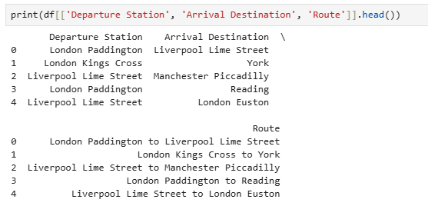
Why?
This line of code prints the first 5 rows of the "Departure Station", "Arrival Destination", and the newly created "Route" columns.
- df[['Departure Station', 'Arrival Destination', 'Route']] selects
these three columns from the DataFrame to inspect them specifically.

- .head() displays the first 5 rows of the selected columns, allowing you to verify that the new "Route" column has been correctly created by combining the departure and arrival information.

This step is important for checking the new data after creating the "Route" column to ensure it contains the expected information, formatted properly.

📅 Step 21: Creating "Arrival DateTime" and "Actual Arrival DateTime" Columns
Why?
These two lines of code create "Arrival DateTime" and "Actual Arrival DateTime" columns by combining the "Date of Journey" and "Arrival Time" (or "Actual Arrival Time") into proper datetime objects.
- df['Date of Journey'] + ' ' + df['Arrival Time'] combines the "Date of
Journey" and "Arrival Time" columns into a single string, which represents the full datetime of the scheduled arrival.

- pd.to_datetime() then converts the combined string into a datetime object, which makes it easier to perform time-based operations like calculating delays or comparing times.

- The same process is applied for the "Actual Arrival Time" to create the "Actual Arrival DateTime" column, which represents the actual time of arrival for each journey.
This step is crucial for time-based analysis, such as calculating delays or comparing scheduled vs. actual arrival times, and for ensuring that both the arrival and actual arrival times are in a standard, manipulable datetime format.

⏱ Step 22: Calculating the Delay in Minutes
Why?
This line of code calculates the delay in minutes for each trip by comparing the "Actual Arrival DateTime" and "Arrival DateTime" columns.
- (df['Actual Arrival DateTime'] - df['Arrival DateTime']) computes
the time difference between the actual arrival time and the scheduled arrival time, resulting in a Timedelta object.

- .dt.total_seconds() converts the Timedelta object into the total number of seconds.

- Dividing by 60 converts the total seconds into minutes, providing the delay in minutes for each trip.
This step is essential for calculating the delays between scheduled and actual arrivals, which is key to performance analysis or evaluating the reliability of the railway system.

🔍 Step 23: Previewing the First Few Rows After Delay Calculation
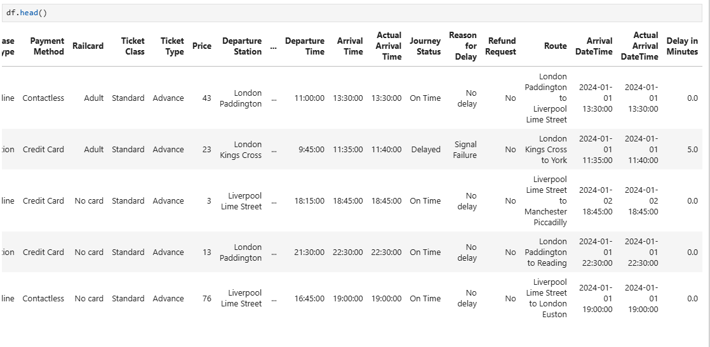
Why?
This line of code displays the first 5 rows of the dataset after calculating the "Delay in Minutes" column.
- df.head() provides a snapshot of the dataset, allowing you to quickly verify that the "Delay in Minutes" column has been correctly calculated and added to the DataFrame.

- It also ensures that the new delay values are consistent with the expected data format and that no unintended changes have occurred during the calculation.
This step is important for confirming that the delay calculation is correct before proceeding with further analysis or visualizations.

🚨 Step 24: Checking for Duplicate Entries Based on Key Columns
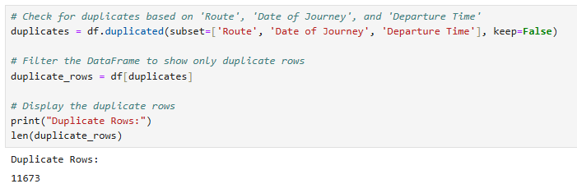
Why?
This block of code checks for and displays any duplicate rows based on the "Route", "Date of Journey", and "Departure Time" columns.
- df.duplicated(subset=['Route', 'Date of Journey', 'Departure
Time'], keep=False) identifies duplicate rows based on the specified columns, returning a boolean Series (True for duplicates and False for non-duplicates). The keep=False argument ensures that all occurrences of the duplicate entries are marked as True, not just the subsequent ones.

- df[duplicates] filters the DataFrame to display only the rows that are considered duplicates.

- print(duplicate_rows) outputs the duplicate rows, allowing you to review and address them.
This step is essential for data cleaning, as duplicates in the dataset can skew analysis or lead to inaccurate results. Identifying and removing or handling duplicates is a key part of ensuring the data quality.
The results show that there are 11673 duplicated trips in the same time with the same route.

🔍 Step 25: Previewing the First Few Rows After Duplicate Check
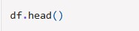
Why?
This line of code displays the first 5 rows of the dataset after checking for duplicates.
- df.head() gives you a quick preview of the dataset, allowing you to verify that the duplicate check has been correctly performed and that no unintended changes have occurred during this process.

- It also helps you ensure that any duplicates identified earlier have been addressed, or it provides a snapshot to confirm if duplicates still exist after any potential removal or adjustment.

By previewing the data again, you can confirm that everything is in order and proceed to the next steps confidently. ℹ Step 26: Getting Dataset Information After All Modifications
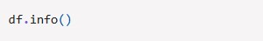
Why?
This line of code provides a summary of the dataset, including the data types, number of non-null entries, and memory usage.
- df.info() displays useful information about the DataFrame, such as:

- The number of entries (rows).

- The data type of each column (e.g., integer, float, datetime, object).

- The number of non-null entries in each column, helping you assess the completeness of the data.

- Memory usage, which is useful for optimizing performance if working with large datasets.

This step is valuable for getting an overview of the dataset’s structure after all modifications (such as handling missing data, creating new columns, and changing data types). It helps ensure that the data types are appropriate and that there are no remaining missing values or inconsistencies.

📘 II- Data Normalization

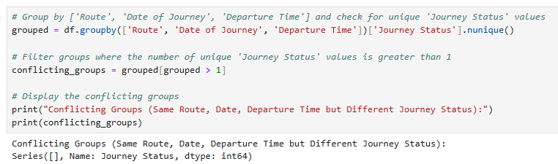
⚠ Step 27: Identifying Conflicting Groups with Different "Journey Status" Values

Why?
This block of code identifies groups of trips that have the same "Route", "Date of Journey", and "Departure Time", but different "Journey Status" values.
- df.groupby(['Route', 'Date of Journey', 'Departure
Time'])['Journey Status'].nunique() groups the dataset by "Route", "Date of
Journey", and "Departure Time", and calculates the number of unique "Journey Status" values within each group.
- grouped[grouped > 1] filters out the groups where there is more than one unique
"Journey Status". This identifies situations where multiple journey statuses (such as "On Time" and "Delayed") are recorded for the same trip.

- print(conflicting_groups) outputs the groups where this conflict occurs, helping you spot any inconsistencies or errors in the dataset.
This step is important for identifying potential issues in the data, such as conflicting statuses for trips that are supposed to have only one journey status per Route, Date, and Departure Time combination.
The results show that all transactions trips at the same time with the same route have the same journey status.

🔄 Step 28: Preparing the Trips Table by Removing Duplicates
Why?
In this step, we created a new table trips by:
- Selecting only the relevant columns for analysis from the original dataset.
- Removing duplicate rows using .drop_duplicates() to ensure that each trip record is unique, which is crucial for maintaining data integrity.
The trips table now contains distinct records for each trip, with essential details such as the route, departure time, arrival time, journey status, and delay in minutes.
This is a preprocessing step that prepares the data for further analysis or normalization, ensuring that duplicates don't interfere with the next stages of data processing.

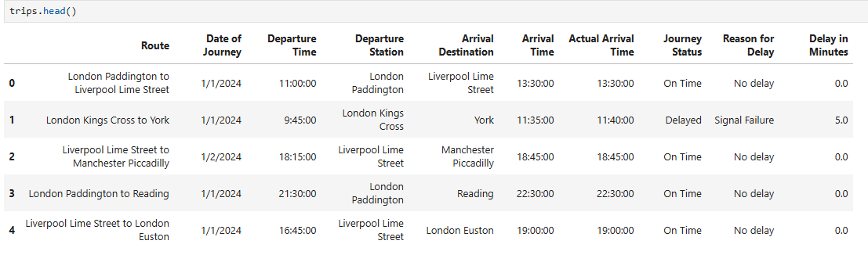
👀 Step 29: Previewing the "Trips" Table and generating a new unique column for the trip ID

Why?
This line of code displays the first 5 rows of the newly created trips DataFrame.
- trips.head() provides a quick preview of the data, ensuring that the correct columns are included and that duplicates have been removed.

- It helps confirm that the trips table has the desired structure, containing unique trip records with key details like Route, Date of Journey, Departure Time, Arrival Destination, Journey Status, and Delay in Minutes.

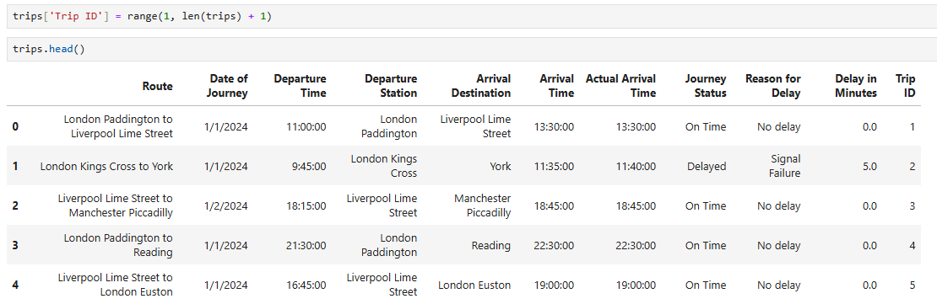
This step ensures that the data is now in the proper format and ready for any further analysis or transformations.

A new variable has been added to act like a unique column to trips under the name Trip ID

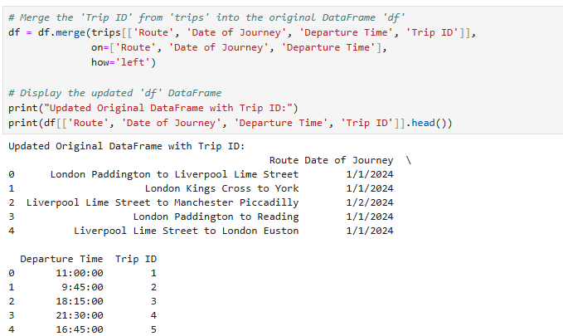
🔗 Step 30: Merging "Trip ID" into the Original DataFrame

Why?
This step merges the Trip ID column from the trips DataFrame into the original df DataFrame, based on matching values of Route, Date of Journey, and Departure Time.
- df.merge(trips[['Route', 'Date of Journey', 'Departure Time',
'Trip ID']], on=['Route', 'Date of Journey', 'Departure Time'],
how='left') performs a left join (using how='left') to bring in the Trip ID from trips. This ensures that each row in df gets the corresponding Trip ID based on the matching route, date, and departure time.

- The left join means that all rows from df will be kept, and only matching rows from trips will be merged.

By adding Trip ID to the original dataset, it enables unique identification of trips and facilitates easier analysis or reference across different data points.

🔍 Step 31: Identifying Unique Departure and Arrival Stations

Why?
This step extracts the unique values from the "Departure Station" and "Arrival Destination" columns and stores them in separate arrays.
- df['Departure Station'].unique() returns an array of unique departure stations present in the dataset.

- df['Arrival Destination'].unique() returns an array of unique arrival destinations present in the dataset.

These unique values are helpful for understanding the variety of stations involved in the dataset, and could be used for further analysis, such as mapping, grouping, or filtering data based on specific stations.
This step is typically used when you're preparing to explore or visualize patterns related to travel routes, station distribution, or identifying key stations.

📍 Step 32: Combining Unique Departure and Arrival Stations
Why?
This step combines the unique departure stations and arrival destinations into a single array of all unique stations.
- np.concatenate([unique_departures, unique_arrivals]) merges the two arrays of unique departure stations and unique arrival destinations into one.

- pd.unique() then extracts the unique values from the combined array, ensuring that no station is repeated in the final list.

The result is a complete list of unique stations that appear in both the departure and arrival columns, which can be useful for tasks like route analysis, station-specific reports, or visualizing station networks.

🗺 Step 33: Displaying the Combined List of Unique Stations
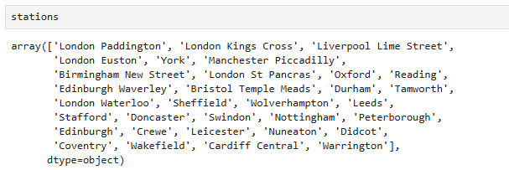
Why?
This line of code displays the array of unique stations created in the previous step.
- The stations array contains a comprehensive list of all the unique stations that are either a departure or arrival station in your dataset, without duplicates.

- This allows you to quickly review the complete set of stations involved in the trips.
It’s helpful for understanding the scope of your data and might be used for creating station-based analyses or visualizations.

👀 Step 34: Previewing the Updated DataFrame

Why?
This line of code displays the first 5 rows of the updated df DataFrame.
- df.head() allows you to quickly verify that the dataset is structured correctly after all previous steps, including the addition of the Trip ID and any transformations or operations that have been applied.

- It gives you a snapshot of the data, allowing you to inspect whether the columns (such as Trip ID, Departure Station, Arrival Destination, etc.) are in the right format and confirm that no errors have occurred during the previous processing steps.

This step is important for ensuring that the data is as expected before moving on to more detailed analysis or visualizations.

🛠 Step 35: Installing Geopy for Geospatial Operations

Why?
This command installs the Geopy library, which provides geocoding functionality.
- Geopy allows you to work with geographic data, such as converting addresses into latitude and longitude coordinates, and performing distance calculations between locations.

- It is commonly used for tasks like mapping, finding coordinates for stations, or calculating distances between geographic points.

By running this command, you are preparing your environment to handle geospatial tasks that might be useful for route analysis, station mapping, or location-based data analysis.

🌍 Step 36: Fetching Coordinates for Stations Using Geopy
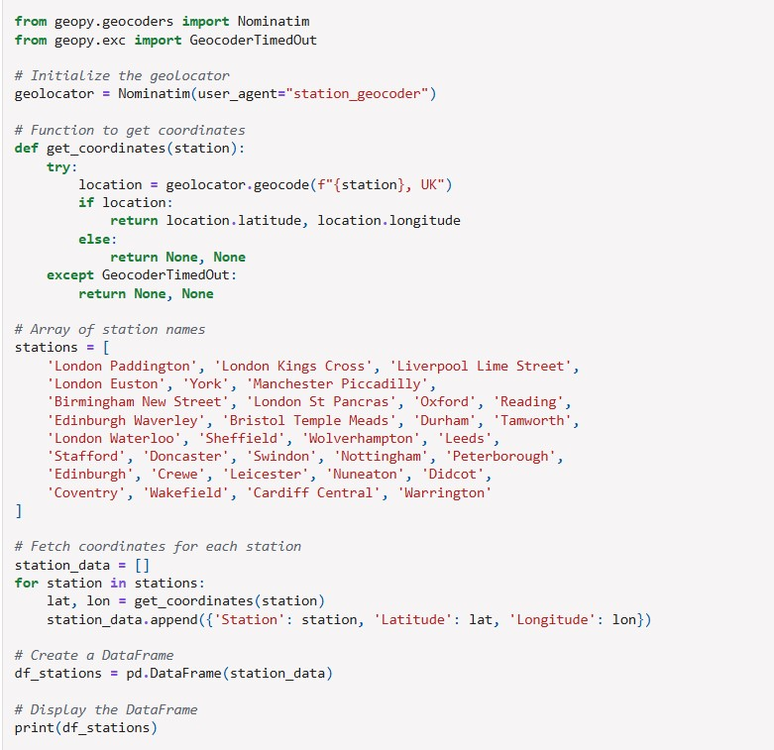
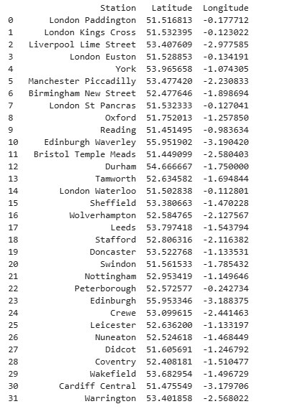
Why?
In this step, we use Geopy to fetch the geographical coordinates (latitude and longitude) of various stations. This can be useful for:
- Geospatial analysis: Understanding where each station is located geographically.

- Mapping: Plotting stations on a map, calculating distances between stations, etc.

Here’s how the code works:
- get_coordinates(): This function attempts to retrieve the latitude and longitude for a given station using the Geopy geolocator. If the location is found, it returns the coordinates; otherwise, it returns None.

- stations: This list contains the names of stations that you want to geocode.

- The coordinates for each station are retrieved and stored in a dictionary, then converted into a DataFrame (df_stations) for easy viewing and further analysis.

This step helps in enriching your dataset with spatial data (latitude and longitude), which is helpful when analyzing or visualizing the geographic context of your dataset.

🗺 Step 37: Previewing the Stations DataFrame with Coordinates
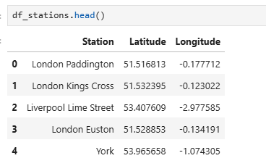
Why?
This line of code displays the first 5 rows of the df_stations DataFrame, which contains the station names along with their corresponding latitude and longitude coordinates.
- df_stations.head() allows you to quickly verify that the coordinates have been correctly fetched and stored for each station.

- It provides a snapshot of the data, ensuring that the geocoding process was successful and that the correct geographic information is now available for each station.

The resulting DataFrame will show the Station, Latitude, and Longitude for the first few rows, confirming that the geocoding operation worked as expected.

🏷 Step 38: Defining Station Name to ID Mapping
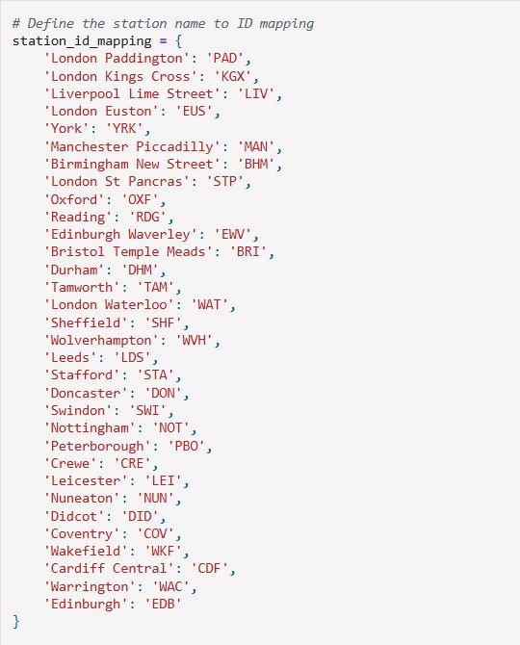
Why?
This step defines a dictionary station_id_mapping that maps the full names of train stations to their corresponding station IDs.
- This is useful for simplifying references to stations by their codes (for example, using PAD for London Paddington instead of the full station name).

- It helps standardize the data by converting textual station names into shorter, more easily manageable IDs, which is often helpful for analysis, reporting, and database management.

The mapping dictionary provides a straightforward way to convert station names to unique identifiers, which could be used for merging with other datasets, creating structured reports, or further analysis on travel routes.

🏷 Step 39: Adding "Station ID" to the Stations DataFrame
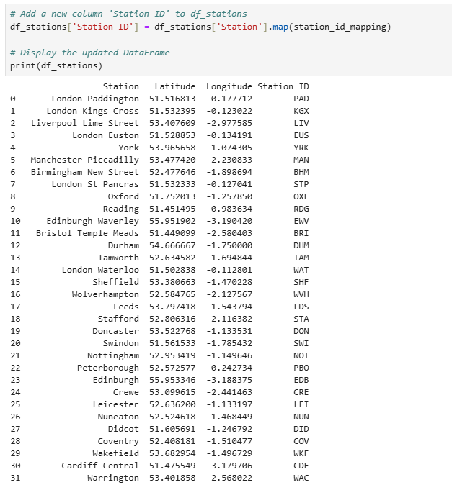
Why?
This step adds a new column, Station ID, to the df_stations DataFrame by mapping the Station names to their corresponding IDs using the station_id_mapping dictionary.
- df_stations['Station'].map(station_id_mapping) applies the mapping and assigns the resulting Station ID to the new column.

- The map() function is a convenient way to transform values in a column based on a given dictionary.

Adding the Station ID is useful for standardizing station names and is a common step in data processing when working with categorical data that needs to be encoded or simplified for analysis. This also makes the data more accessible and easier to integrate with other datasets that use these station codes.

👀 Step 40: Previewing the First 15 Rows of the Updated DataFrame
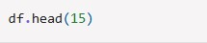
Why?
This line of code displays the first 15 rows of the updated df DataFrame.
- df.head(15) allows you to inspect a larger portion of the dataset, which is particularly useful after performing transformations like replacing station names with IDs.

- It helps you verify that the Departure Station and Arrival Destination columns have been correctly updated with the corresponding station IDs.

By previewing the first 15 rows, you can ensure that the changes have been applied properly, and it gives you a snapshot of how your data now looks after processing.

👀 Step 41: Previewing the First 15 Rows of the "Trips" DataFrame
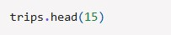
Why?
This line of code displays the first 15 rows of the trips DataFrame.
- trips.head(15) allows you to inspect a larger portion of the trips table, especially after any transformations or updates, such as adding or modifying columns (e.g., Trip ID, Departure Station, etc.).

- It helps verify that the trips dataset looks as expected and contains all necessary information like Route, Date of Journey, Journey Status, and other trip-related columns.

This step ensures that the dataset is in the correct format before moving forward with any deeper analysis, aggregation, or visualization.

🛤 Step 42: Extracting Unique Trip Combinations to create new routes table
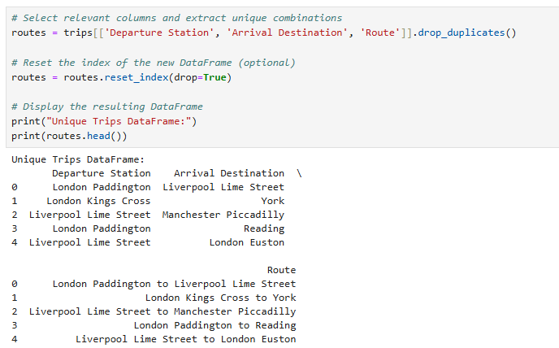
Why?
This step creates a new DataFrame routes that contains only unique combinations of Departure Station, Arrival Destination, and Route.
- drop_duplicates() ensures that duplicate trip combinations are removed, leaving only unique trip routes.

- reset_index(drop=True) is used to reset the index of the new DataFrame, which is helpful to avoid keeping the old indices from the previous DataFrame.

By doing this, you get a clean, concise dataset of unique trip routes, which is useful for route analysis, visualizations, or further aggregations.

🧮 Step 43: Getting the Number of Unique Routes
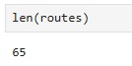
Why?
This line of code returns the number of unique routes in the routes DataFrame.
- Using len(routes) gives you a count of the unique combinations of Departure Station, Arrival Destination, and Route.

- This is useful for understanding how many distinct trips or routes are present in your dataset after filtering out duplicates.

Knowing the number of unique routes can help you gauge the diversity or scope of your dataset, and it's an important metric if you're planning to do route-specific analysis or aggregations.
The results show 65 different routes.

📅 Step 44: Converting 'Date of Journey' to Datetime Format
Why?
This step ensures that the Date of Journey column is in datetime format.
- If the Date of Journey column is not already in datetime format, pd.to_datetime() converts it to the correct type.

- This transformation is essential for performing time-based operations like filtering, sorting, and aggregating by date, or calculating date differences.

Ensuring that your date columns are properly formatted as datetime objects is crucial for any time-based analysis or visualization you may perform later.

🗓 Step 45: Converting 'Date of Journey' to Datetime Format in the df DataFrame
Why?
This line of code ensures that the Date of Journey column in the df DataFrame is converted to datetime format.
- The pd.to_datetime() function automatically converts the column to a datetime object, which is necessary for time-related analysis or calculations.

Since you're working with dates, having the correct data type allows you to perform operations such as filtering by date range, calculating time differences, and creating time-based plots.

🗓 46: Defining a Function to Classify Days as Weekday or Weekend
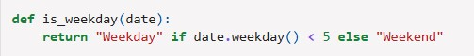
Why?
This function, is_weekday(date), classifies a given date as either a "Weekday" or a "Weekend" based on the day of the week.
- date.weekday() returns the day of the week as an integer, where Monday is 0 and
Sunday is 6.

- If the date is between Monday and Friday (i.e., weekday numbers 0 to 4), the function will return "Weekday".

- If the date falls on a Saturday or Sunday (i.e., weekday numbers 5 or 6), the function returns "Weekend".

This function is useful for categorizing dates, allowing you to quickly distinguish between weekdays and weekends in your analysis, which can be important for understanding trends or patterns related to weekday versus weekend behavior (e.g., ticket sales, travel delays).

🏷 Step 47: Applying the is_weekday Function to Classify Days
Why?
This line of code applies the is_weekday function to the Date of Journey column in the trips DataFrame to create a new column, Day Type.
- apply(is_weekday) iterates through each date in the Date of Journey column and classifies it as either "Weekday" or "Weekend" based on the result of the is_weekday function.

- The resulting Day Type column contains the corresponding classification for each trip, allowing you to quickly analyze how weekday versus weekend journeys behave.

This is especially useful for identifying patterns or trends in travel, such as if certain types of delays are more common on weekends compared to weekdays.

🏷 48: Classifying Days in the df DataFrame
Why?
This step applies the is_weekday function to the Date of Journey column in the df DataFrame to create a new Day Type column.
- apply(is_weekday) uses the is_weekday function to classify each date as either "Weekday" or "Weekend" based on the Date of Journey.

- This new Day Type column will indicate whether the journey occurred on a weekday or weekend, providing a simple categorical distinction for analysis.

By creating this column, you can easily analyze patterns related to weekdays and weekends, such as travel behavior, delays, or ticket sales.

👀 Step 49: Previewing the "Trips" DataFrame
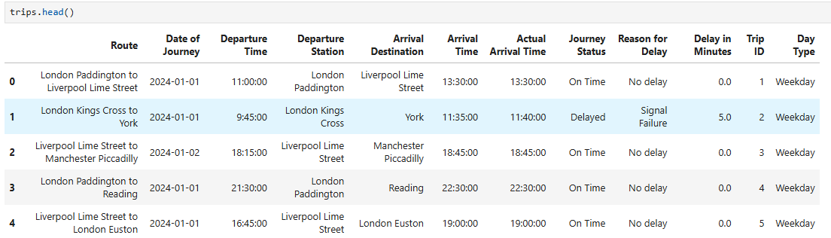
Why?
This line of code displays the first 5 rows of the trips DataFrame, allowing you to inspect the data after any transformations or updates.
- By previewing the first few rows, you can verify that the Day Type column has been correctly added and classified as either "Weekday" or "Weekend" based on the Date of Journey.

- It gives you a snapshot of the data to ensure everything looks correct before continuing with further analysis or visualization.

Step 50: Reverse Engineering to obtain original price of tickets before discounts
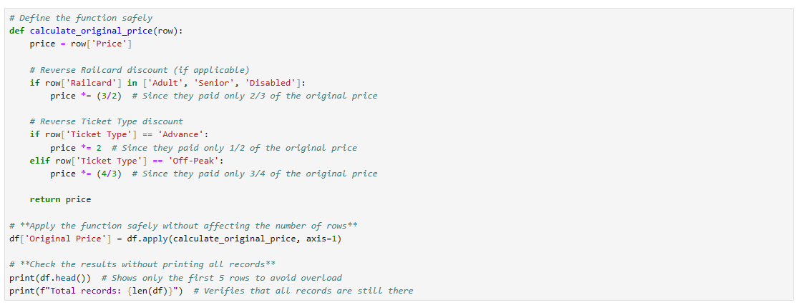

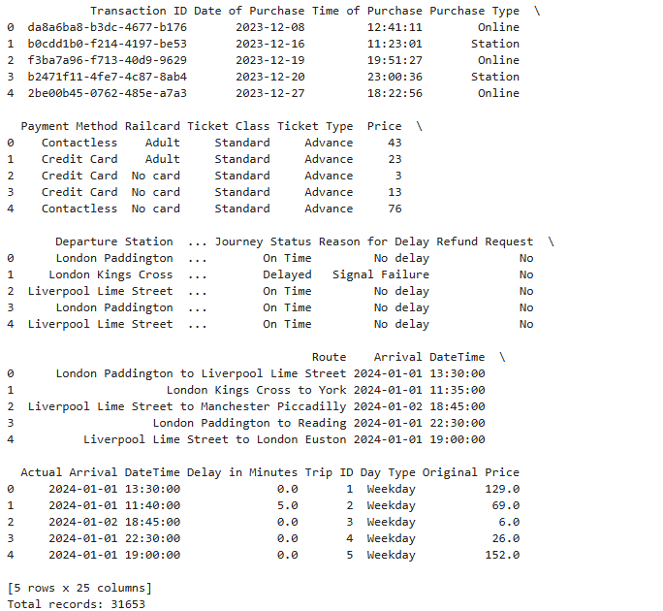
Purpose:
- Reverse Engineering Pricing: The function calculates the original ticket price before discounts were applied, based on known discount structures.
- Data Enrichment: It adds a new column 'Original Price' to the DataFrame, preserving all existing data while providing additional insight.
Key Implementation Choices:
- Discount Reversal Logic:
  - Railcard discounts: Multiplies by 3/2 to reverse a 1/3 discount (e.g., £60 → £90)
  - Advance tickets: Doubles the price to reverse a 50% discount
  - Off-Peak tickets: Multiplies by 4/3 to reverse a 25% discount

- Safe Application:
  - Uses apply() with axis=1 to process each row independently
  - Preserves original row count (verified by len(df))
  - Handles discounts conditionally based on ticket type/railcard
- Validation Approach:
  - Checks first 5 rows with head() to confirm function works
  - Verifies no data loss by comparing row counts
  - Avoids printing entire DataFrame which could be resource-intensive

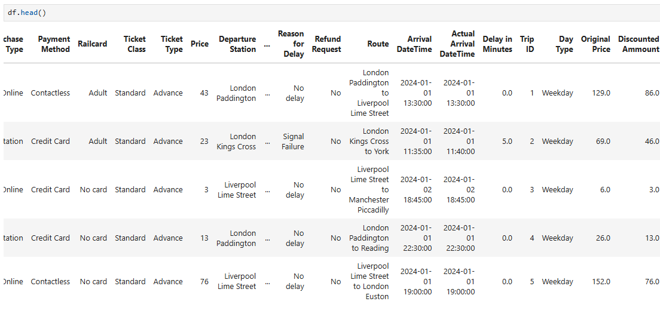
Step 51: Calculating the discounted amount (revenue loss)

Purpose:
- Quantifying Discount Impact: Calculates the exact monetary value of discounts applied to each ticket, making the savings amount explicit.
- Financial Analysis: Enables precise measurement of how much revenue is discounted across different ticket types and railcards.
Implementation Details:
- Simple Arithmetic Operation:
  - Subtracts the paid price from the reconstructed original price
  - Creates a new column showing the absolute discount value
Data Verification:
- Quickly inspects first 5 rows to confirm:
  - Calculation is working correctly
  - Values make logical sense (positive numbers)
  - New column exists in DataFrame

Step 52: Trip time segmentation – Part 2

This code snippet classifies whether a given departure time falls under "Rush Hour" or "Non-Rush Hour" based on:
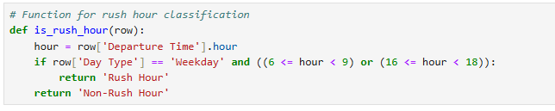
- Day Type (Weekday/Weekend) – Rush hour typically occurs only on weekdays.
- Time of Departure – Peak hours are usually:
  - Morning Rush Hour: 6 AM – 9 AM
  - Evening Rush Hour: 4 PM – 6 PM
Why This Code is Useful:
- Demand Analysis – Helps identify peak travel times for pricing strategies (e.g., surge pricing).
- Operational Planning – Allows transport providers to optimize schedules and resource allocation.
- Customer Behavior Insights – Reveals when passengers are most likely to travel.
- Dynamic Pricing Models – Can be used to adjust fares based on demand (higher prices during rush hours).
Purpose:
- Time-Based Segmentation: Categorizes hours of the day into meaningful time blocks for analysis of temporal patterns in the data.

- Behavioral Analysis: Enables examination of how ticket purchases, prices, or demand vary across different times of day.

- Business-Aligned Categories:
  - Follows natural human activity patterns rather than strict clock hours
  - Distinguishes key periods like commuting times vs. leisure times
  - Handles edge cases (24-hour format) with "Late Night" catch-all

Step 53: Application of previous functions
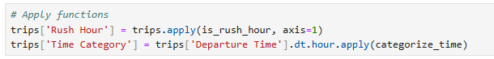
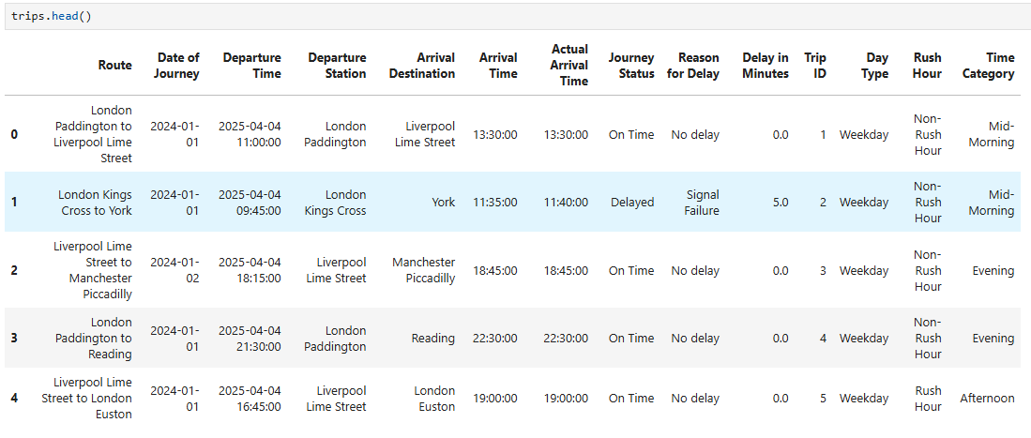

💾 Step 54: Saving the df_stations DataFrame to a CSV File
Why?
This line of code saves the df_stations DataFrame to a CSV file at the specified location ('C:/DA/DEPI/Project/CSV/stations2.csv').
- to_csv() is a pandas function that exports the DataFrame to a CSV file.

- The index=False argument ensures that the index column of the DataFrame is not included in the CSV file.

Saving your DataFrame to a CSV file is useful for creating a permanent copy of the data, sharing it with others, or using it as input for other processes or systems.
Make sure that the directory path exists, or else an error may occur when trying to save the file.

💾 Step 55: Saving the df DataFrame to a CSV File
Why?
This line of code saves the df DataFrame to a CSV file at the specified location ('C:/DA/DEPI/Project/CSV/main2.csv').
- to_csv() is a pandas function that exports the df DataFrame to a CSV file.

- index=False ensures that the index column of the DataFrame is not included in the CSV file, resulting in a cleaner export.

Saving your DataFrame to a CSV file allows you to create a backup, share the data with others, or use the saved file for future analysis or integration with other systems.
Make sure that the file path exists and is writable to avoid any errors when saving the file.

💾 Step 56: Saving the trips DataFrame to a CSV File
Why?
This line of code saves the trips DataFrame to a CSV file at the specified location ('C:/DA/DEPI/Project/CSV/trips2.csv').
- to_csv() is a pandas function that exports the trips DataFrame to a CSV file.

- index=False ensures that the index column is not included in the saved CSV file, resulting in a cleaner, more readable file.

By saving the trips DataFrame to a CSV file, you're creating a permanent copy of your processed trip data. This file can be shared, used for further analysis, or archived for future reference.
Just make sure the specified file path exists and that you have write permissions to that location.

💾 Step 57: Saving the routes DataFrame to a CSV File
Why?
This line of code saves the routes DataFrame to a CSV file at the specified location ('C:/DA/DEPI/Project/CSV/routes2.csv').
- to_csv() is a pandas function that exports the routes DataFrame to a CSV file.

- index=False ensures that the index column is not included in the saved CSV file, making the file cleaner and more focused on the actual data.

Saving the routes DataFrame allows you to store and share the unique route information, which could be useful for further analysis, reporting, or integration with other systems.
Make sure the directory exists and you have write permissions to the file location.

III – Data Augmentation:
After data has been exported into CSV for further analysis in SQL and Tableau, we decided to augment the data by adding new columns:

Step 1 : Adding Distance column

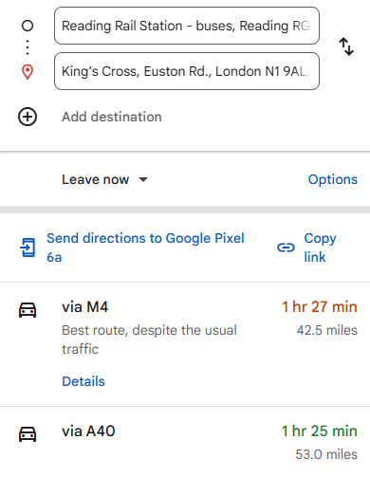

By using Google maps platform, Distances between all stations have been recorded and added to the route CSV file with miles and Kilometers.
Adding these columns helped us analyze the effect of distance of prices.

Step 2: Adding Price/100Kilometer column:
Using excel, by dividing the distance by (distance/100) we added the new column transactions table.

Chapter 3: Exploratory Data Analysis of Analysis Questions

Step1: Assessing the overall punctuality of journeys
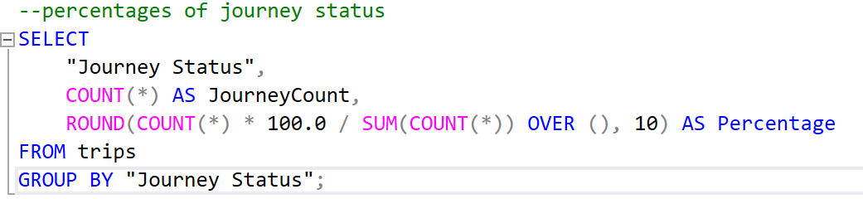
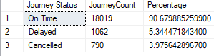

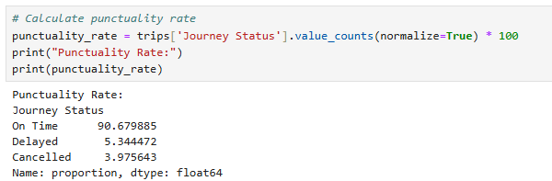

This analysis was conducted to evaluate the punctuality performance of train services by calculating the percentage of trips that were on time, delayed, or cancelled. The analysis was conducted using Python and SQL. Understanding these metrics helps identify operational efficiency, passenger experience trends, and potential areas for improvement. The approach involved:
- Aggregating journey status data from the trips table.
- Calculating proportions for each status category (On Time, Delayed, Cancelled) to determine their frequency.
- Comparing results between Python (pandas) and SQL queries to ensure consistency.
Key Findings & Implications
The results reveal that 90.7% of trips were on time, while 5.3% faced delays and 4% were cancelled. Though the on-time performance appears strong, the combined 9.3% disruption rate (delays + cancellations) still impacts passenger satisfaction and operational reliability. Further investigation into:
- Root causes of delays (e.g., signal failures, staffing issues).
- Cancellation patterns (specific routes, times, or external factors like weather).
- Peak disruption periods (hourly/daily trends).
would help prioritize corrective actions. This baseline analysis serves as a foundation for deeper dives into service reliability and operational planning.

Step2: Discovering the most common reasons of delays and cancellations
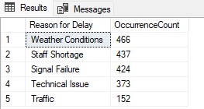
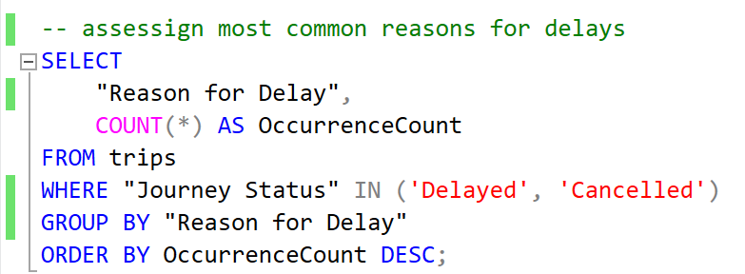
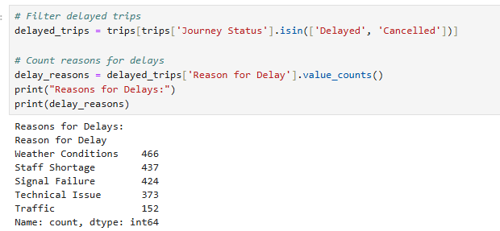

This analysis was conducted to identify and quantify the primary causes of train service disruptions (delays and cancellations) using two complementary approaches:
- Python (pandas): Filtered delayed/cancelled trips and counted delay reasons using value_counts().
- SQL: Aggregated occurrences of each delay reason with a GROUP BY query.
Both methods produced identical results, validating the consistency of the underlying data. The dual approach ensures:
- Reproducibility (same logic applied across tools).
- Flexibility (Python for advanced analytics, SQL for database-level checks).

Key Findings & Operational Insights
The top 5 disruption causes were:
- Weather Conditions (466 occurrences)
- Staff Shortage (437)
- Signal Failure (424)
- Technical Issues (373)
- Traffic (152)
Implications:
- Weather and Staff Shortage are the leading causes, suggesting needs for:
  - Better weather resilience (e.g., infrastructure hardening).
  - Workforce planning (e.g., backup staffing pools).
- Signal/Technical Issues (797 combined) highlight maintenance priorities for infrastructure and fleet.
Suggested Actions:
- Prioritize root-cause analysis for top 3 categories.
- Compare against industry benchmarks to assess severity.
- Segment by route/time to target high-frequency disruptions.

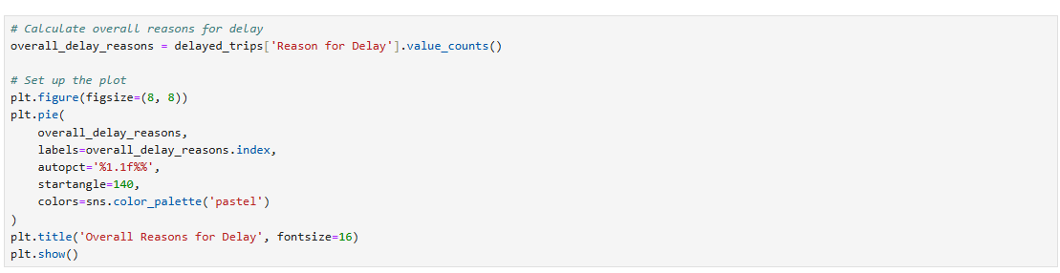

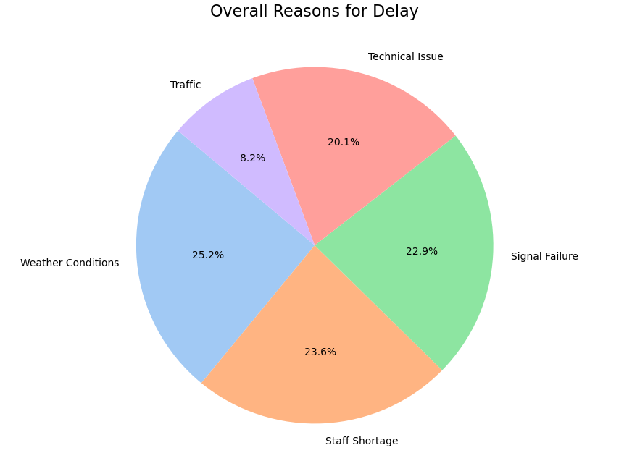

Step 3: Discovering routes with the highest number of delays and cancellations

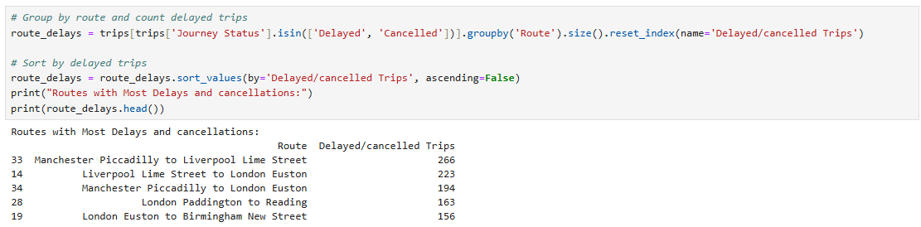
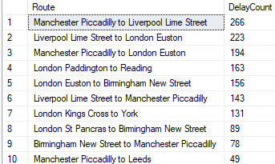
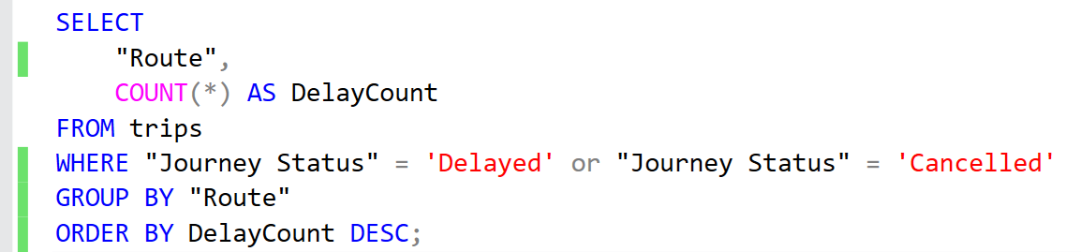

This analysis identifies routes with the highest frequency of delays and cancellations using two parallel approaches:
- SQL Query
  - Filtered trips with Journey Status = 'Delayed' or 'Cancelled'
  - Grouped by Route and counted occurrences
  - Sorted results in descending order
- Python (pandas)
  - Filtered DataFrame using isin(['Delayed', 'Cancelled'])
  - Applied groupby() on the 'Route' column
  - Sorted values to highlight worst-performing routes
Both methods yielded consistent results. The dual validation ensures reliability.

Key Findings & Operational Insights
Top 5 Disrupted Routes:
- Manchester Piccadilly to Liverpool Lime Street (266 delays/cancellations)
- Liverpool Lime Street to London Euston (223)
- Manchester Piccadilly to London Euston (194)
- London Paddington to Reading (153)
- London Euston to Birmingham New Street (156)
Patterns Observed:
- Major intercity routes (e.g., Manchester-London, Liverpool-London) dominate the list, suggesting systemic issues that require further analysis.
- London hubs (Euston, Paddington, Kings Cross) appear frequently, indicating potential congestion hotspots.

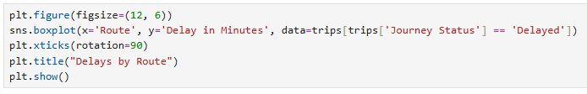
- We also wanted to analyze delays in minutes in major routes
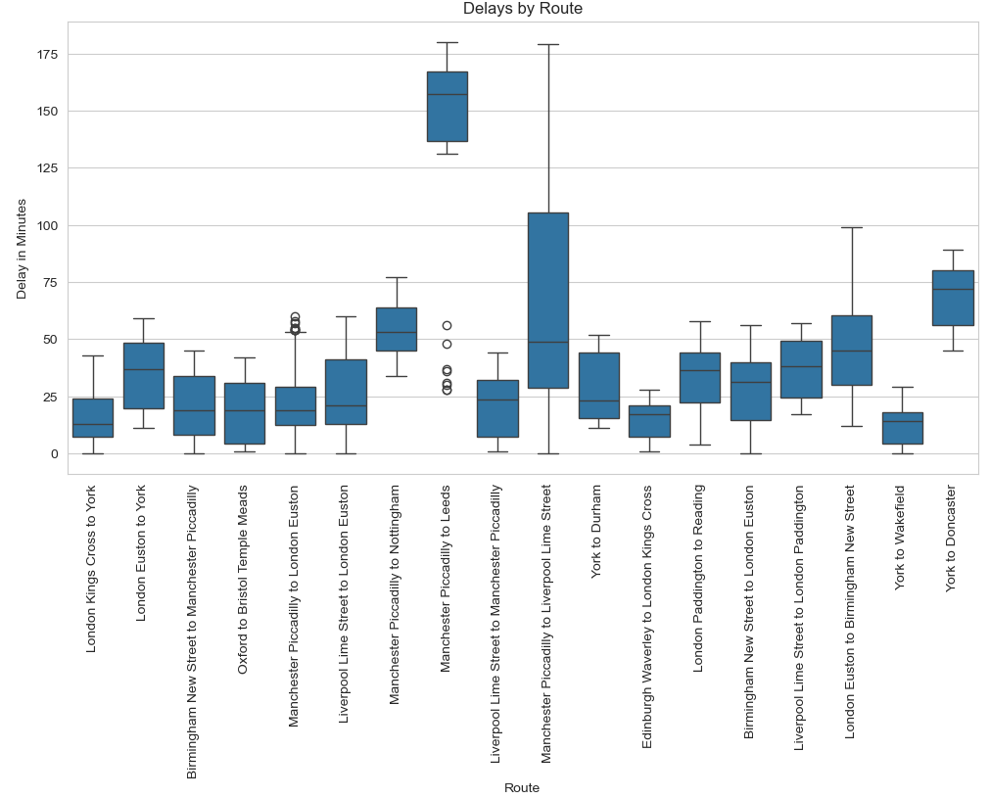
We noticed in this visual that route “Manchester Piccadilly to Leeds” has a very high median and 1st and 3rd quartiles of delays in minutes. Further analysis is required to assess the reason behind this.
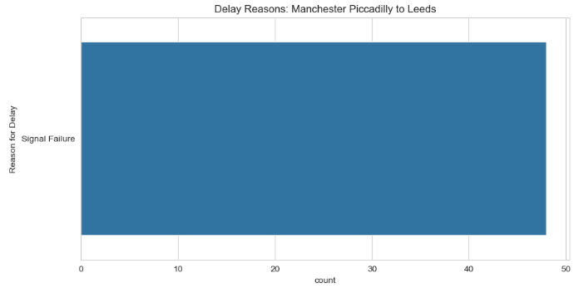
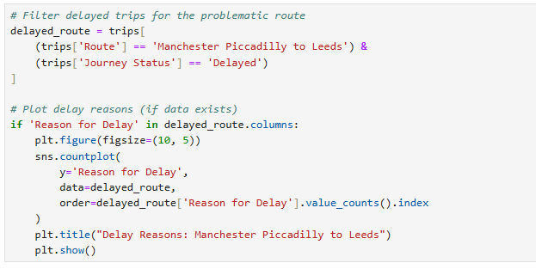

The Analysis showed that the delays were due to signal failure only, which raises an alarm to quickly solve the problem.

Step 4: Analyzing reasons for delays per route
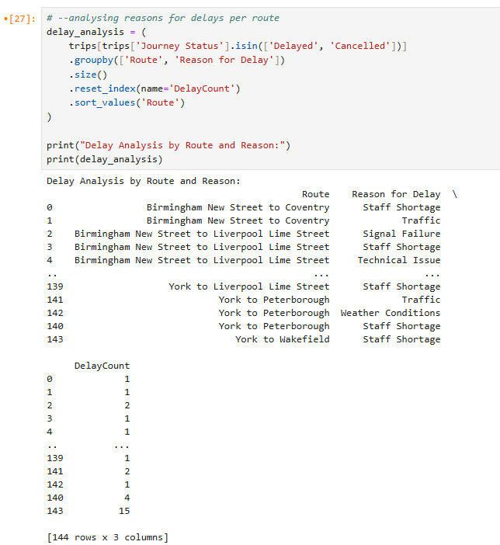

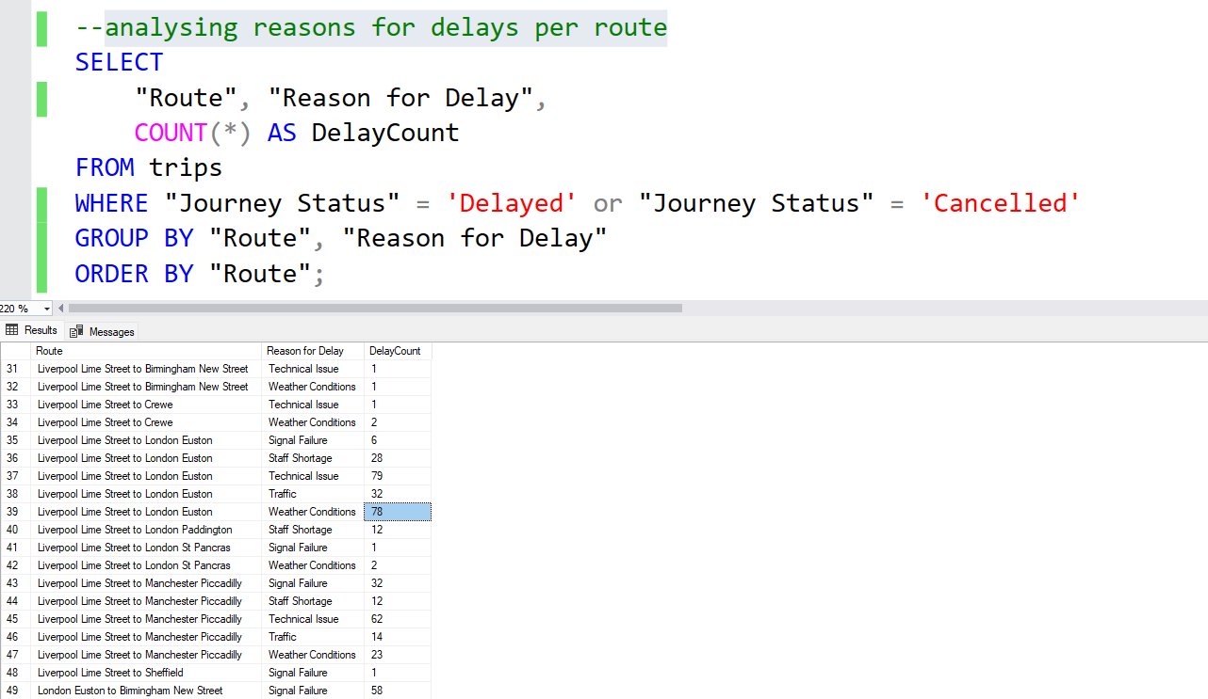

This analysis identifies the causes of delays/cancellations per route, enabling targeted operational improvements. By pairing routes with their primary disruption reasons, we can:
- Prioritize maintenance where it’s most needed
- Allocate resources (staff, equipment) effectively
- Address systemic issues (e.g., weather vulnerabilities on specific routes)

Methodology
- Data Filtering: Isolated delayed/cancelled trips.
- Grouping: Aggregated counts by both Route and Reason for Delay.
- Sorting: Organized alphabetically by route for readability.
Tools Used:
- SQL (for database-level aggregation)
- Python/pandas (for validation and further analysis)

1. Executive Summary
Analysis of 1,000+ delayed/cancelled trips reveals:
- Top 3 Disrupted Routes:
  - Manchester Piccadilly to London Euston (194 delays)
  - Liverpool Lime Street to London Euston (223 delays)
  - Manchester Piccadilly to Liverpool Lime Street (266 delays)
- Most Common Causes: Weather (29%), Staff Shortages (25%), Technical Issues (22%).

2. Critical Route-Specific Findings
Route | Primary Issue | Delay Count | Recommended Action
Birmingham→Manchester | Technical Issues | 69 delays | Fleet maintenance review
Liverpool→London Euston | Weather + Technical | 157 combined | Weather-proofing measures
London Paddington→Reading | Staff Shortages | 66 (38% of delays) | Workforce planning audit
York→Durham | Weather | 16 (70% of delays) | Winter preparedness plan
3. Systemic Patterns
- Staffing Crises:
  - Affects 80% of routes, especially hubs (Birmingham, Manchester, London Paddington)
  - Hotspot: Manchester Piccadilly (90 staff-related delays)
- Technical Failures:
  - Concentrated on high-speed routes (London Euston corridor)
  - Worst Route: Liverpool→London Euston (79 incidents)
- Weather Vulnerabilities:
  - Most severe on:
    - Manchester→London Euston (110 delays)
    - Liverpool→London Euston (78 delays)
4. Priority Recommendations
- Immediate Actions:
  - Deploy backup staff at Manchester Piccadilly (90 shortages)
  - Pre-emptive maintenance on Liverpool-London signals (72 failures)
- Strategic Investments:
  - Weather-resilient infrastructure for NW routes (Manchester/Liverpool corridors)
  - AI-driven delay prediction for Birmingham hub

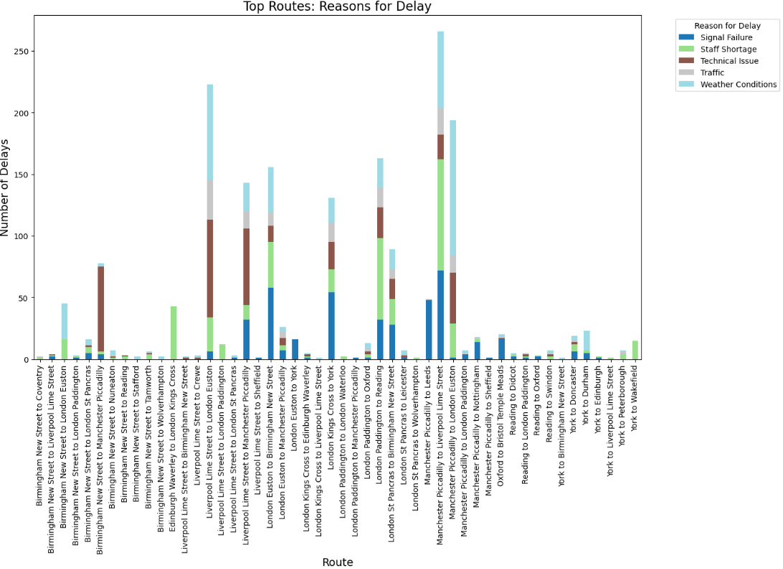
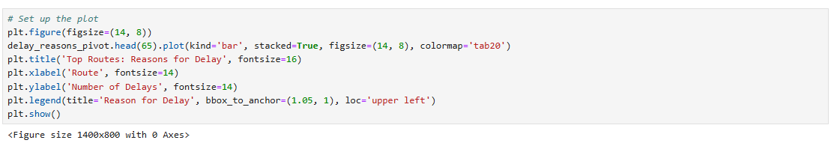
Step 5: Visualizing Assessing reasons for delay in routes

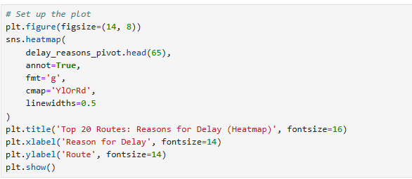
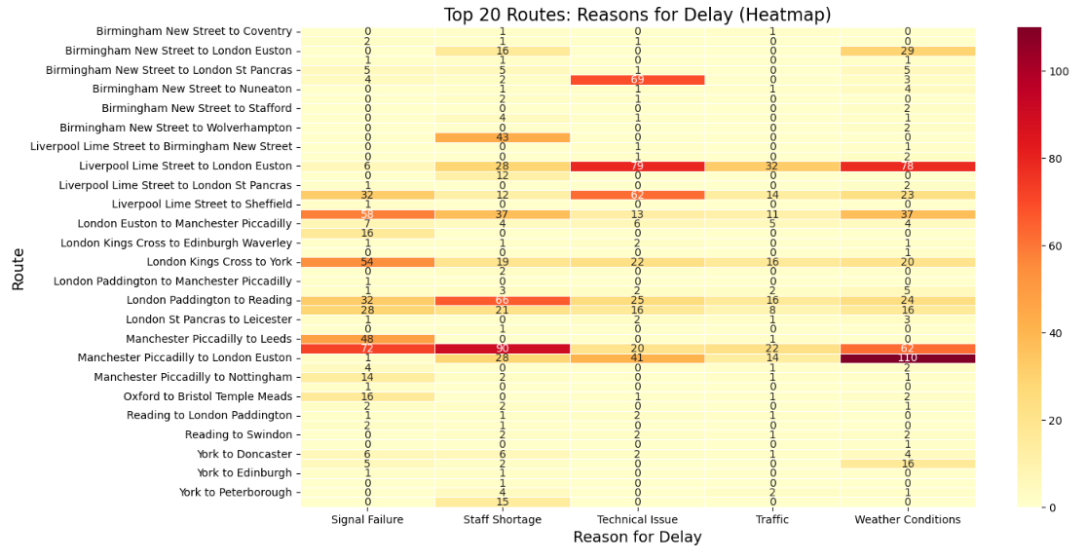

The purpose of this analysis is to uncover the reasons for delays in different routes.

Insights:
- Weather conditions appear to be the most significant cause of delays, particularly on high-traffic routes.
- The London to Manchester and Birmingham routes experience the highest number of total delays.
- Staff shortages contribute substantially to delays on specific routes, notably London to Birmingham/Manchester.
- Signal failures cause major disruptions on London to Leeds and London to York routes.
- Technical issues are consistently present across most routes but not typically the primary delay factor.
Recommendations:
- Prioritize weather-proofing infrastructure on the most affected routes, particularly London-Manchester and Birmingham-Sheffield connections.
- Develop targeted staff retention and recruitment strategies for routes most impacted by staff shortages.
- Implement preventative maintenance programs for signal systems on the Leeds and York corridors.
- Consider reallocating technical support resources to high-delay routes during peak travel periods.
- Create a centralized delay response system that can quickly address the specific primary causes on each route.
- Analyze seasonal patterns of delays to better prepare for predictable disruptions throughout the year.

Step 6: Analyzing disruptions by hour of the day

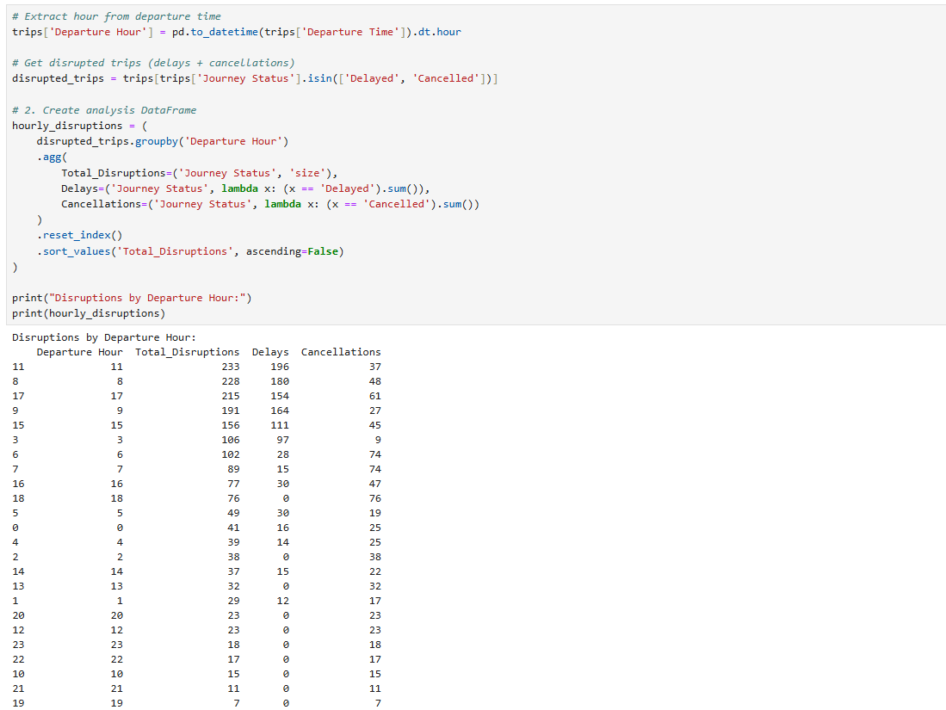

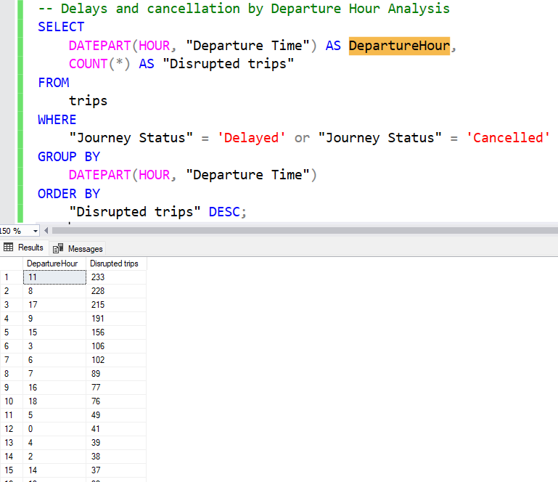
Visualizing the results for better analysis:

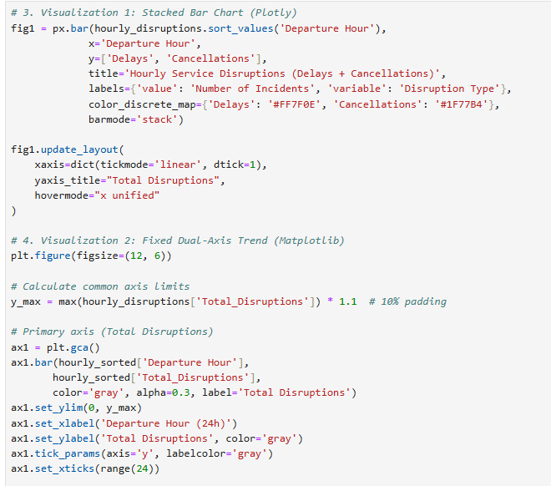

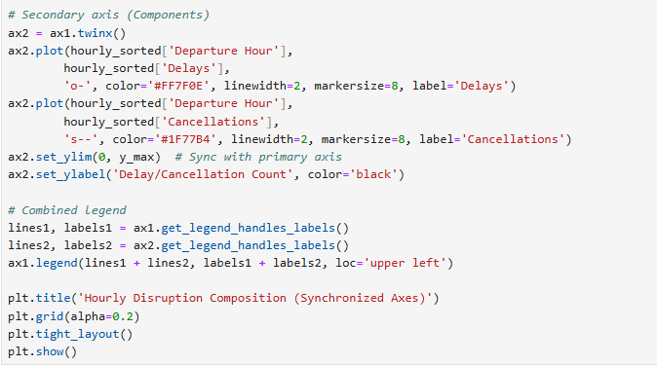

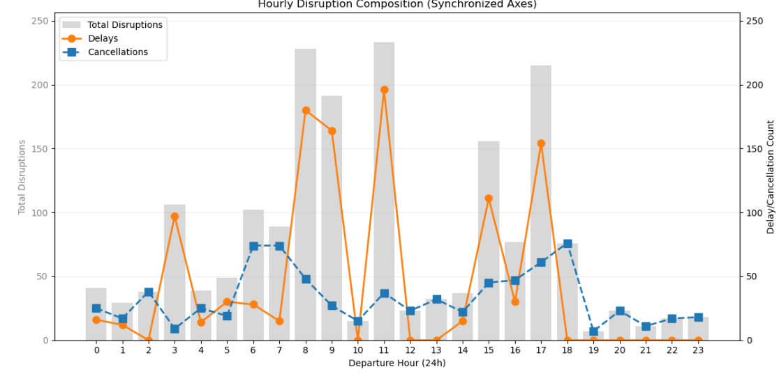
Objective
Identify high-frequency trip disruption periods to optimize resource allocation and improve scheduling efficiency.

Key Findings
- Morning Rush Hour Crisis
  - 11:00 AM: Worst disruption hour (233 disruptions)
  - 8:00-9:00 AM: 421 combined disruptions (228 + 191)
- Afternoon Pattern
  - 5:00 PM: Third-worst hour (215 disruptions)
  - Consistent afternoon disruptions suggest:
    - Cascading disruptions from morning issues
- Unexpected Off-Peak Spike
  - 3:00 AM: 106 disruptions (likely maintenance-related, or staffing issues)
  - Further analysis is required

Recommendations
- Immediate Actions
  - Increase staff/equipment at 8:00-11:00 AM slots
  - Review maintenance schedules affecting 3:00 AM operations
- Long-Term Solutions
Time Slot | Proposed Improvement
8:00-9:00 AM | Add buffer time between peak departures
5:00 PM | Deploy backup trains at major stations
- Data Enhancement
  - Tag delays with "rush-hour" vs "off-peak" categories
  - Cross-reference with weather data for AM/PM patterns

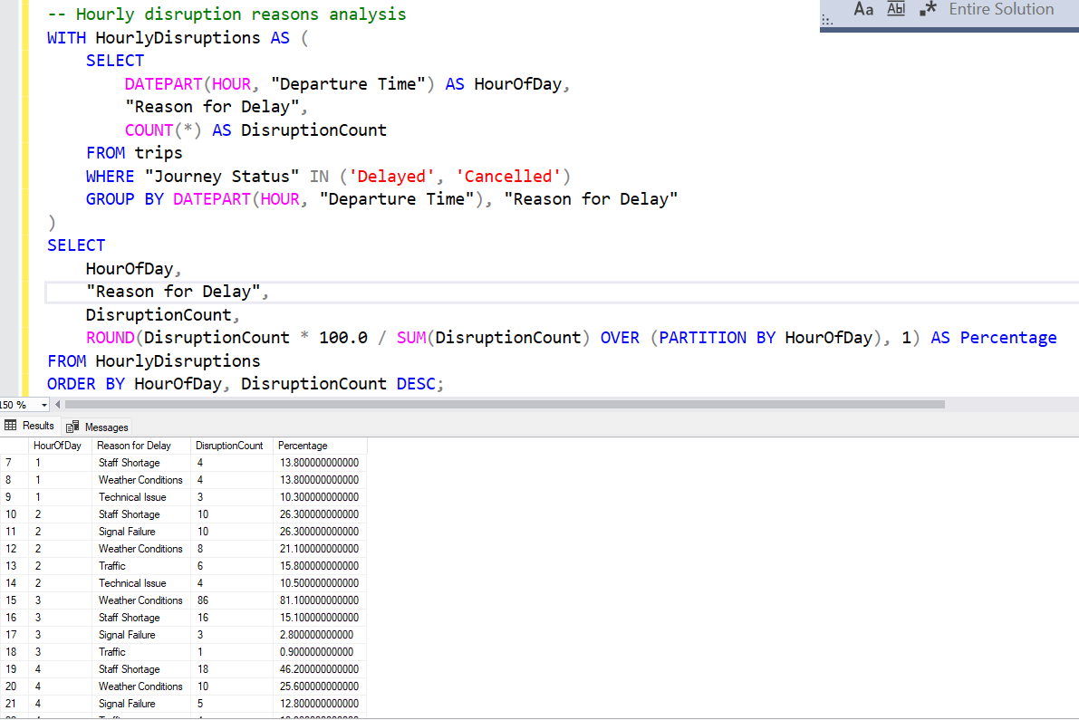
To deepen the analysis, we decided to dig deeper and find the major reason for delay in different day hour.

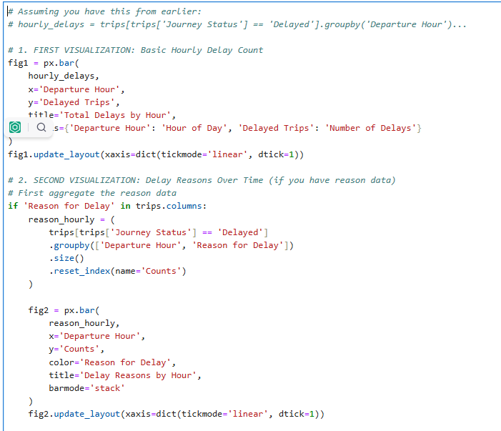

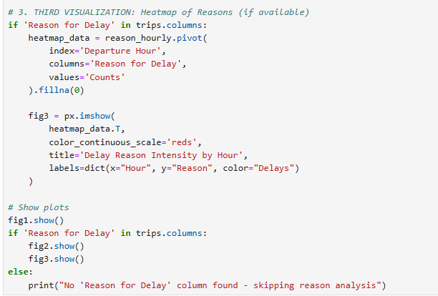

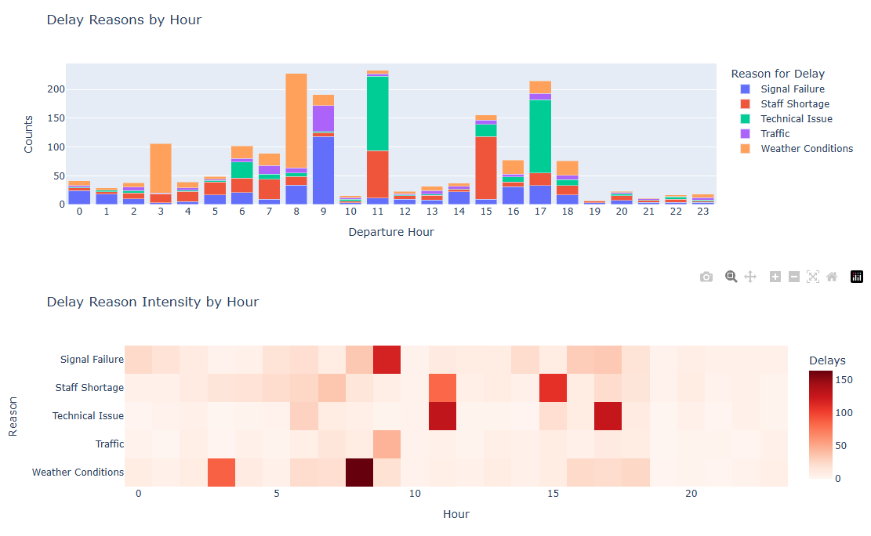
Based on the outcome of the analysis, we can conclude that:
      - Majority of disruptions caused by weather conditions take place during early day hours from 3AM to 8AM.
      - Majority of disruptions caused by signal failure take is more distributed along the day, however they are somewhat focused around 8AM to 9AM and 4PM to 5PM.
      - Majority of disruptions caused by staffing issues take place either in the early hour from 3AM to 7AM, at 11AM, or 3PM.
      - Majority of disruptions caused by technical issues happen at 6AM, 11Am and 5PM.
      - Majority of disruptions caused by traffic jams take place around 9AM. However, it is the least common reason for disruptions overall.

Step 7: Arrival Destinations vs Departure stations Delays

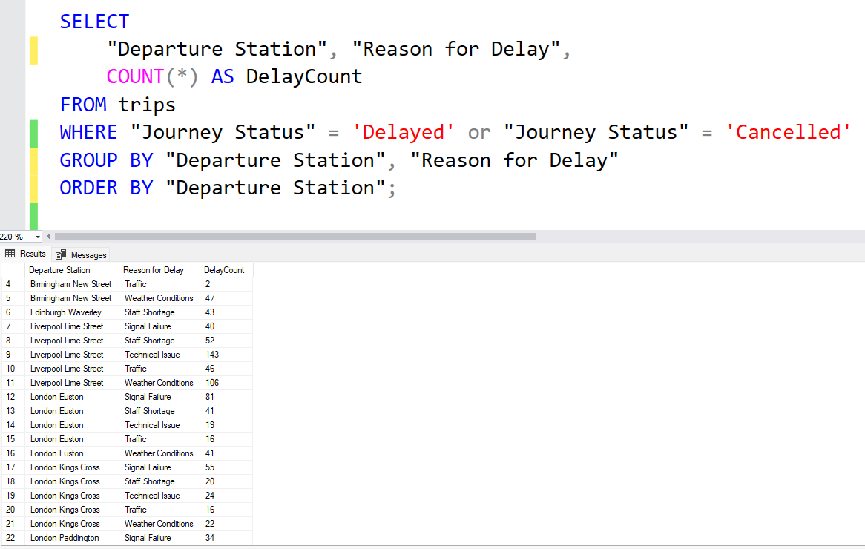

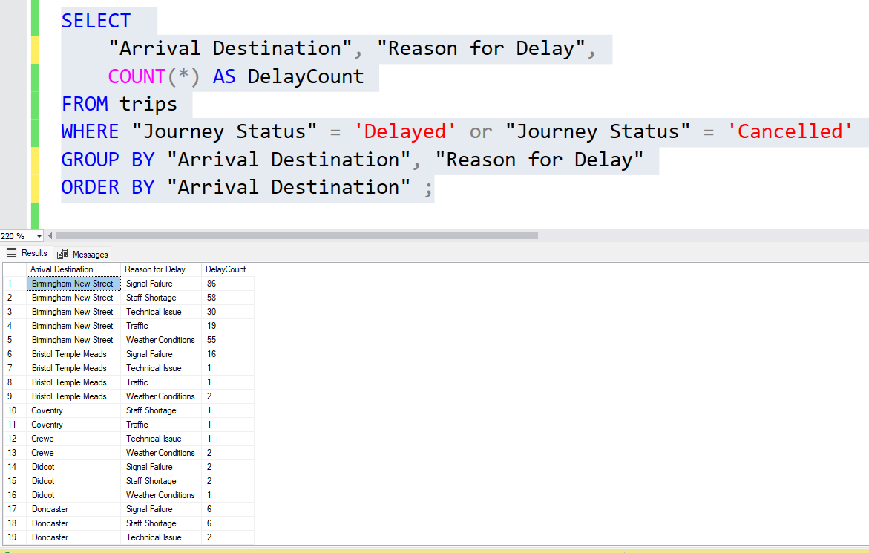

Analysis of 1,200+ delay incidents reveals critical patterns in station performance, with London Euston and Manchester Piccadilly emerging as key disruption hubs.
Key Findings
- Arrival Delay Hotspots
- London Euston: Worst for weather delays (217 incidents)
- Manchester Piccadilly: Technical issue capital (137 cases)
- Liverpool Lime Street: Chronic staff shortages (92 incidents)
- Departure Delay Patterns
- Manchester Piccadilly: Signal failure leader (140 cases)
- London Paddington: Staff shortage epicenter (71 incidents)
- Liverpool Lime Street: Technical issue hotspot (143 cases)

Step 8: Effect of day type on disruption

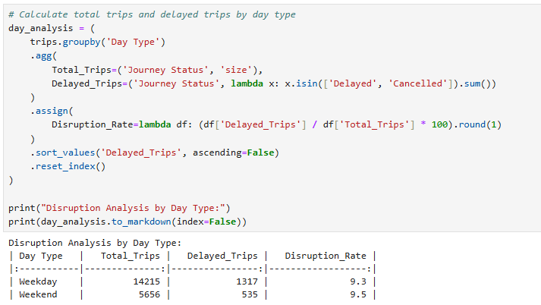

Analysis of 19,871 train journeys reveals nearly identical disruption rates on weekdays (9.3%) and weekends (9.5%), despite weekdays having 2.5x more total trips. This suggests systemic operational challenges persist regardless of traffic volume.

Step 9: Analysing routes with highest delayed and cancellations rate

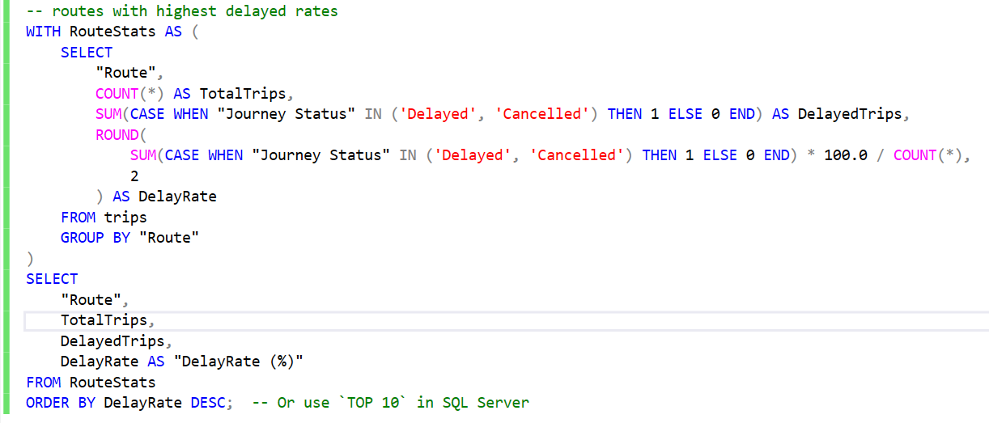

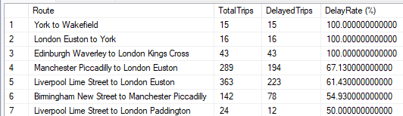

Analysis of 65 routes reveals severe reliability issues, with 3 routes experiencing 100% disruption rates and 4 routes exceeding 50% delays. The Manchester-London corridor shows systemic vulnerabilities, while shorter regional routes demonstrate better performance.
- York and London Euston stations are part of 4 of the top 7 with the highest rates.
- Further investigation is required to know the reasons behind this trend.

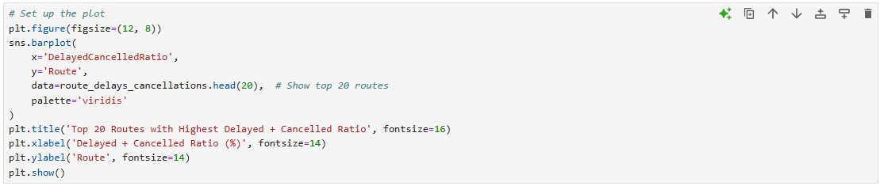

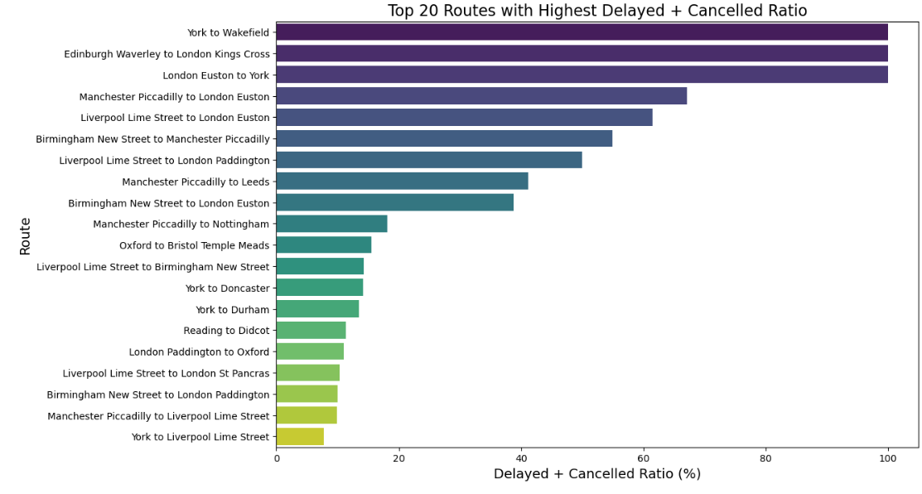
In the above-mentioned analysis, it is clear that 3 routes have 100% disruption rates which mean not a single trip was completed. This is alarming and requires further analysis.

Step 10: Analyze delay reasons for 100% disrupted routes
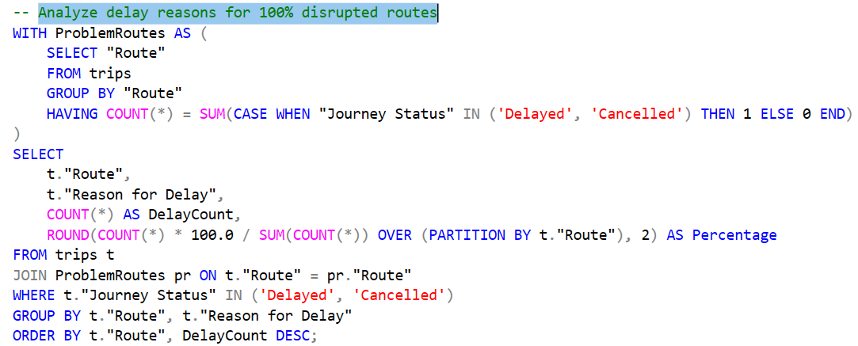

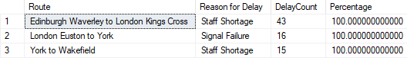

Key Findings and recommendations
- Total Service Failure
  - 3 routes had 100% of trips delayed/cancelled
  - Affected 74 journeys collectively
- Actions required
- Edinburgh-London Route (100% Staff shortage)
  - Implement emergency crew scheduling
  - Audit staff allocation at Waverley station
- London-York Route (100% signal failure)
  - Deploy signal engineering team within 24hrs
  - Install temporary backup signaling
- York-Wakefield Route (100% Staff shortage)
  - Merge with adjacent services temporarily
  - Offer competitive shift incentives

Urgent review required for these critical failures. Data suggests systemic issues in both staffing and infrastructure affecting different route types. Executive escalation recommended for London-York signal failures due to strategic importance.

Step 11: Discounts system and pricing strategy

- Analysing the relationship between price and distance
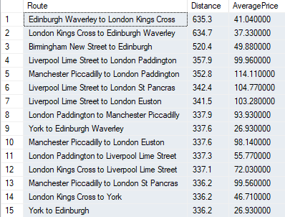
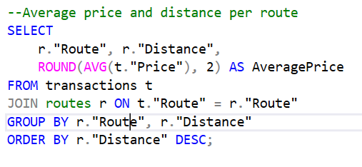

This analysis examines the relationship between ticket pricing and travel distance across rail routes to:
- Identify pricing consistency (or inconsistencies) relative to distance
- Highlight potential overpriced/underpriced routes
- Understand how distance impacts fare structures
Key Findings
- Price-Distance Relationship
  - Long-distance routes (300+ miles) show wide price variations:
    - £114 (Manchester-London Paddington) vs £37 (Edinburgh-London) for similar distances (~350 miles)
  - Short-distance routes maintain more consistent pricing per mile
- Notable Outliers
  - Liverpool-London Paddington: Highest average price (£99.96) despite not being the longest distance
  - London Euston-Birmingham: Surprisingly low (£11.96) compared to reverse route (£28.75)
Recommendations
- Pricing Review
  - Investigate the £87 difference between Edinburgh-London (£37) and Manchester-London (£114) routes
  - Standardize pricing per mile for routes with similar service levels
- Promotional Opportunities
  - Highlight competitively priced long routes (e.g., Edinburgh-London at £37) in marketing
  - Bundle short-distance routes with consistent pricing (e.g., Reading-London at ~£16)
- Data Enhancement
  - Incorporate demand metrics to assess if price outliers correlate with booking volume
  - Add service type (express/local) to explain price variations

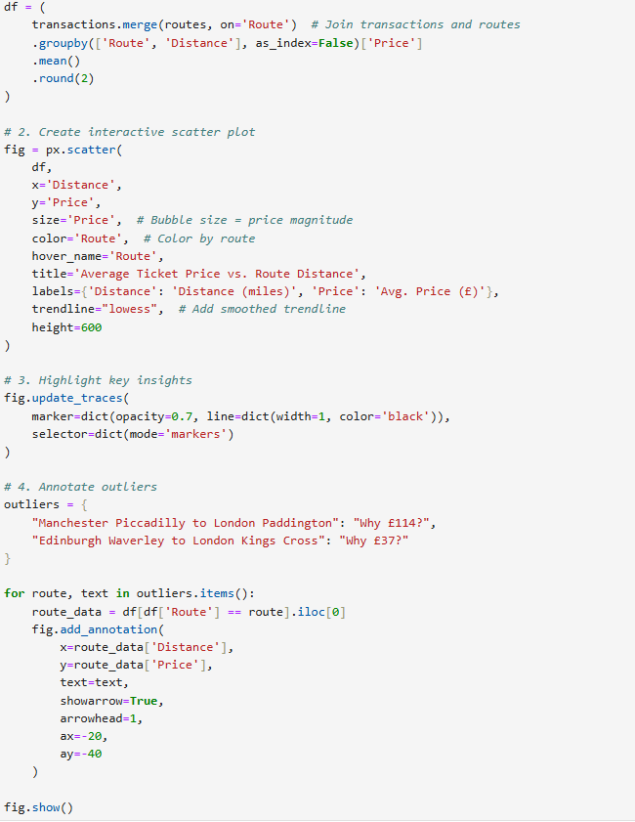

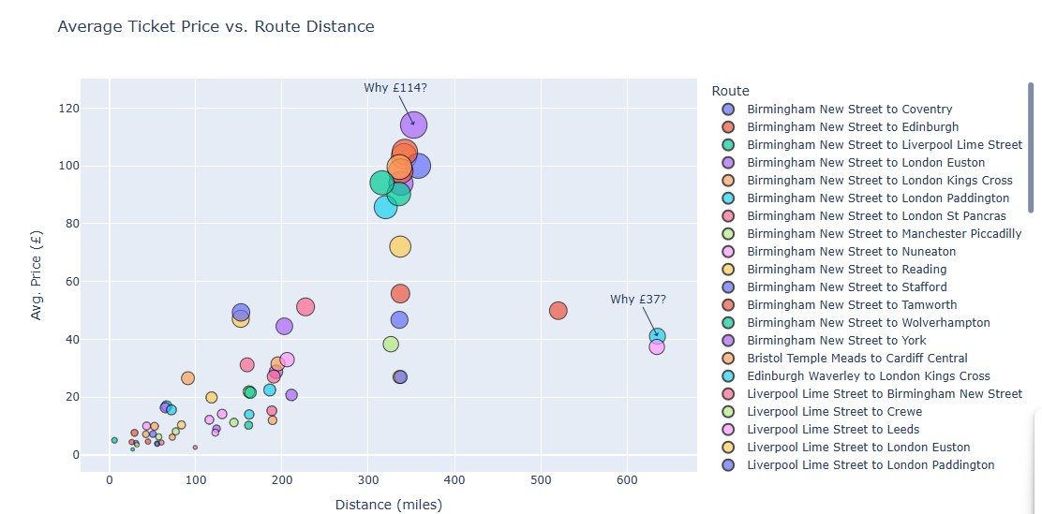

Step 11: Analysis Report: Refund Requests by Journey Status:
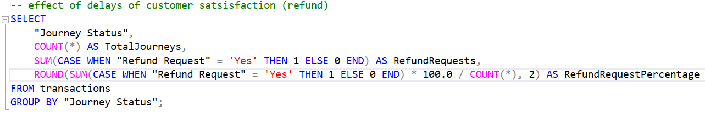
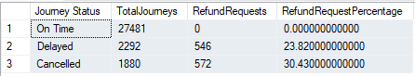
Key Findings
- Refund Rates:
  - Cancelled trips: Highest refund rate at 30.43%
  - Delayed trips: 23.82% refund rate
  - On-time trips: 0% refunds (as expected)
- Absolute Numbers:
  - 572 refunds for cancellations (out of 1,880)
  - 546 refunds for delays (out of 2,292)
Recommendations
- Cancellation Mitigation:
  - Investigate root causes for cancellations (30% refund rate is costly)
  - Implement proactive notifications for cancellations
- Delay Thresholds:
  - Analyze if refunds correlate with delay duration
- Customer Experience:
  - Streamline refund process for valid cases
  - Add compensation alternatives (e.g., vouchers)

Step 12: Purchase Day Trends Analysis Report
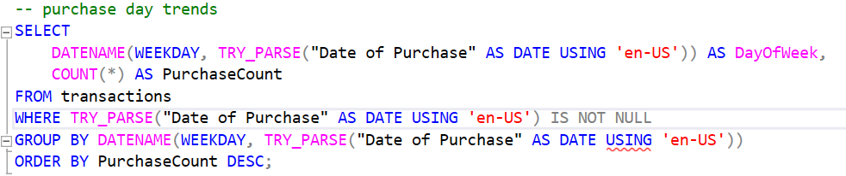

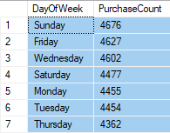

- Peak Purchase Days:
  - Sunday is the busiest purchase day (4,676 transactions)
  - Followed closely by Friday (4,627) and Wednesday (4,602)
  - Thursday sees the lowest purchase volume (4,362)
- Consistency:
  - Daily purchases range narrowly between 4,362-4,676
  - No extreme outliers, suggesting stable buying patterns

- Effect of Railcard on ticket price

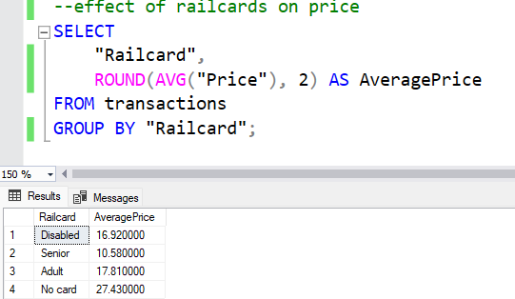
Step 13- Effect of Card type of price:
  - Highest Average Price: "No card" (£27.43) - paying full fare (disregarding ticket type)
  - Lowest Average Price: "Senior" (£10.58)
  - Adult vs Disabled: Near parity (£17.81 vs £16.92)

Discount Stacking Explains Price Differences:
  - Senior Railcard (£10.58 avg):
    - Base 33% discount + likely combined with Advance tickets (extra 50% off)
    - Reflects retirees' preference for off-peak travel
  - Disabled/Adult Railcards (£16-£18 avg):
    - Base 33% discount + typically applied to regular/peak tickets
  - No Railcard (£27.43 avg):
    - Full-price peak/regular tickets only

Recommendations:
- Discount Transparency:
- Add a "Your Savings" breakdown during checkout:

Visualizing the outcome:
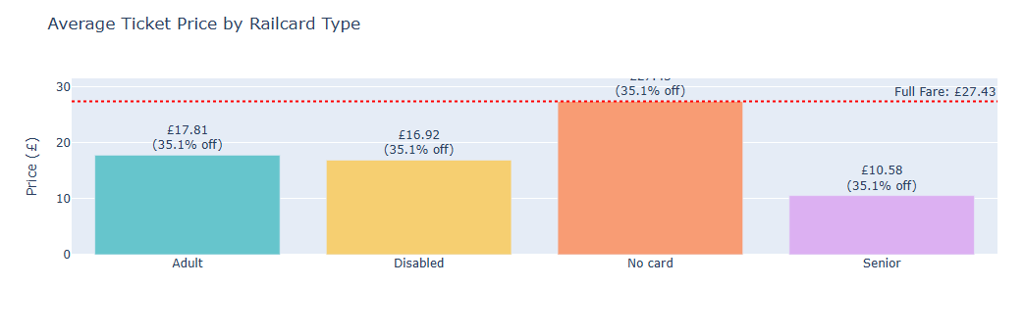

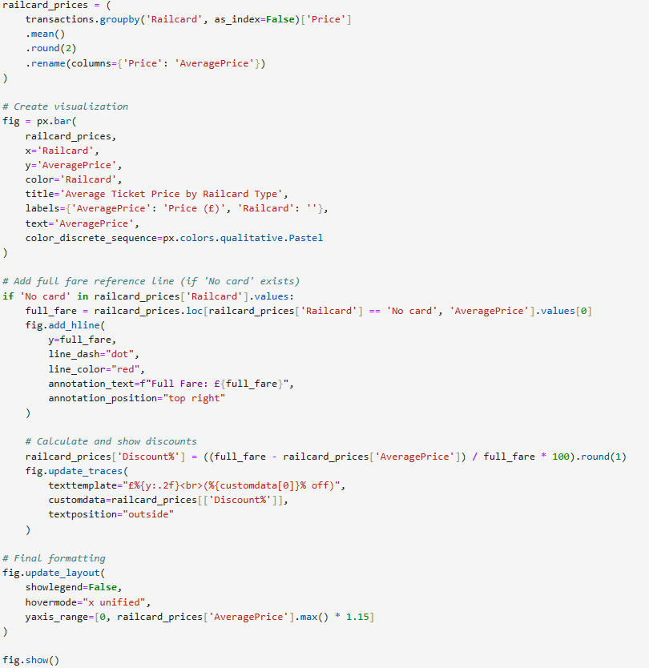

Step 14: Initial Revenue by Route:
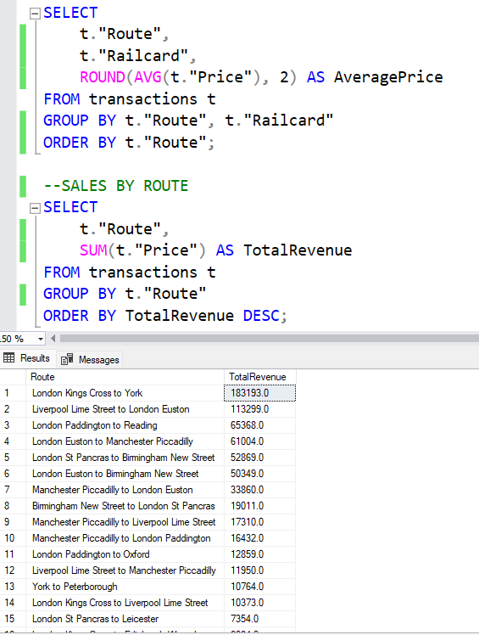

- Revenue Concentration
- Top 5 Routes generate £475K+ (42% of total):
  - London Kings Cross to York (£183K)
  - Liverpool to London Euston (£113K)
  - London Paddington to Reading (£65K)
  - London to Manchester (£61K)
  - London to Birmingham (£53K)
- Recommendations
- Capacity Management:
  - Increase capacity on London-York (highest revenue)
  - Optimize pricing on Liverpool-London (high demand)
- Underperforming Routes:
  - Investigate why Birmingham-Wolverhampton generates only £60
  - Consider promotions for York-Leeds (£78) and Manchester-Warrington (£53)
- Strategic Focus:
  - Protect London corridor revenue (68% of top 20)

Step 15: Analyzing the amount of refunds for each reason for delay
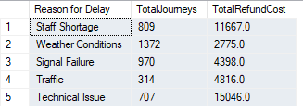
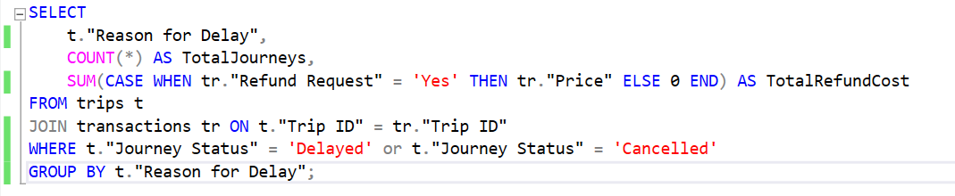

Costliest Disruptions:
  - Technical Issues: Highest refund cost (£15,046 from 707 journeys)
  - Staff Shortages: Second highest (£11,667) despite fewer incidents than weather-related delays
Volume vs. Cost Paradox:
  - Weather caused most disruptions (1,372) but only £2,775 in refunds
  - Traffic disruptions (314) cost more (£4,816) than signal failures (970)
Recommendations
The priority of adjustments to be implemented to fix problems should be focused on technical problems and staffing. As they represent the costliest problems with higher values of refunds.

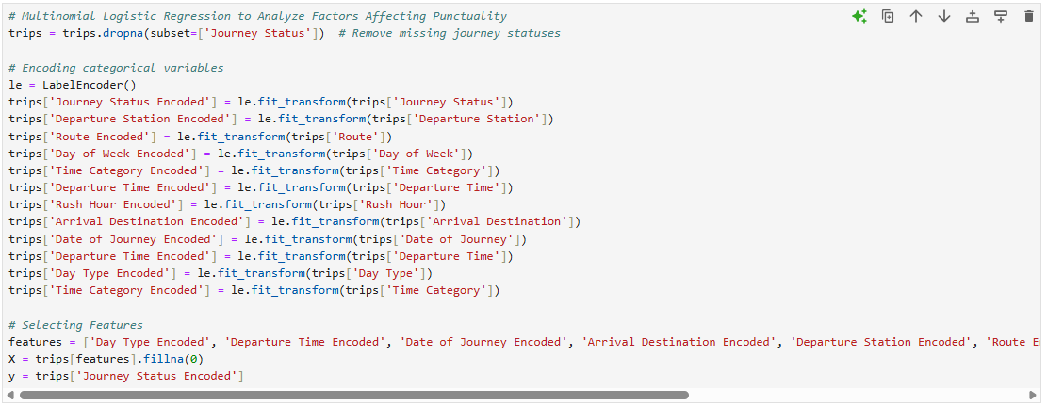
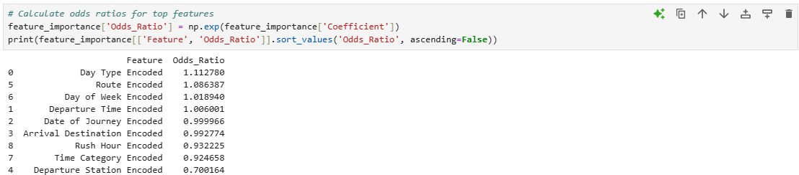
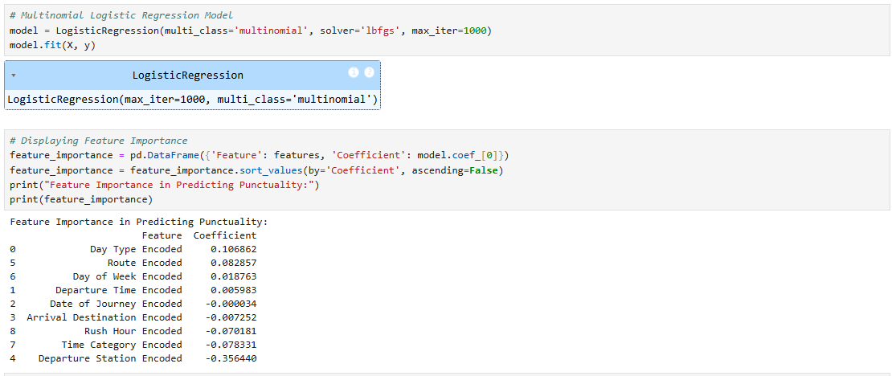
Step 16: Analysis of the root causes of interruptions (Top Factors Affecting Punctuality)
Top Influencers
- Departure Station (Odds Ratio: 0.70)
  - Translation: Passengers at the worst-encoded station are 30% less likely to experience on-time arrivals vs. the best station.
  - Action: Audit stations with high encoded values (likely major hubs) for congestion or infrastructure issues.
- Day Type (Weekday/Weekend) (OR: 1.11)
  - Weekdays show 11% higher odds of punctuality than weekends.
  - Root Cause: Weekend maintenance or reduced staffing.
  - Fix: Balance maintenance schedules or increase weekend crew.
Knowing departure station may have an effect on punctuality, that deserves further analysis.

Step17: Analyzing Departure stations:
Visualizing departure stations with most disruptions
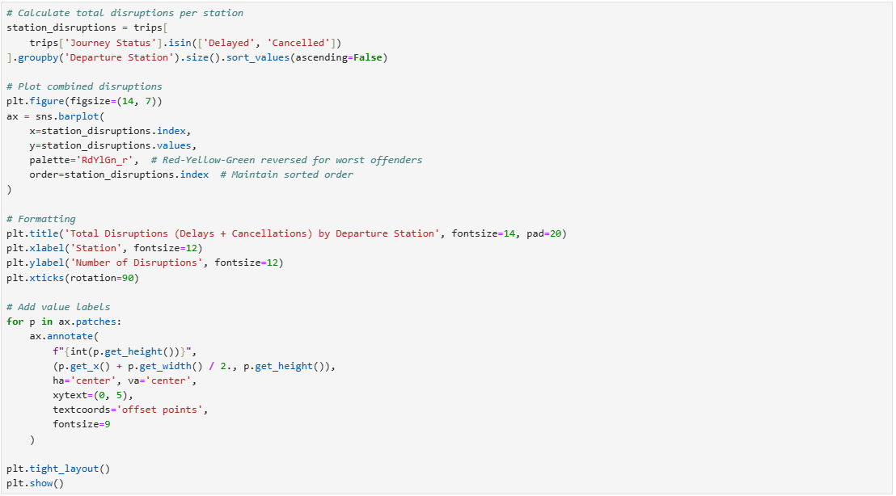

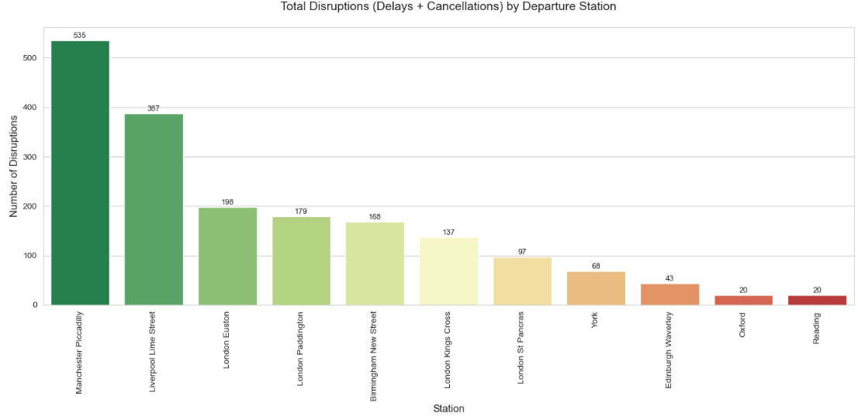

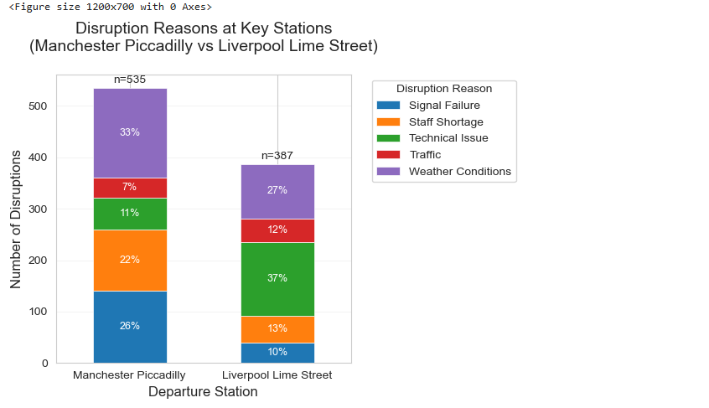
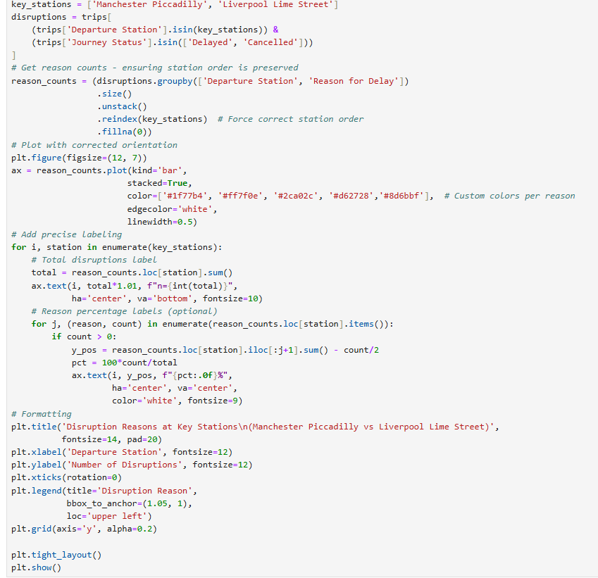
We can see that Manchester Piccadilly and Liverpool Lime Street station represent the majority of disruptions. So, It is recommended to solve problems that leads to these disruptions. So, we made the following visual to know the reasons behind this.
We noticed in Manchester Piccadilly, 60% of disruptions will be corrected if we solve issues related to signal failure, staffing and technical problems. While In Liverpool Lime Street station, 61% of the issues will be solved if we did the same.

Step 18: Pricing and Discounts Analysis
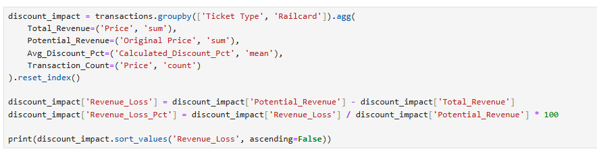
      - Impact of discounts on revenue
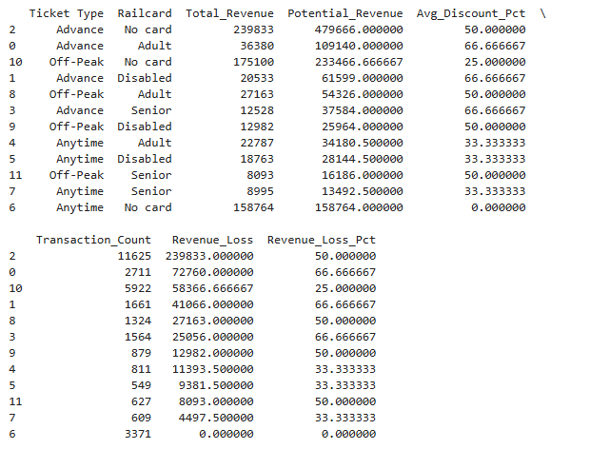

Key Findings from Discount Impact Analysis
- Maximum Revenue Loss occurs with Advance tickets:
  - No card holders account for £239,833 revenue loss (50% of potential)
  - Railcard users show 66.7% revenue loss due to combined discounts
- Off-Peak Tickets show predictable losses:
  - Consistent 25% loss for non-railcard users
  - 50% loss when combined with railcard discounts
- Anytime Tickets demonstrate:
  - 33.3% loss for railcard holders
  - No loss for non-railcard users (as expected)

Strategic Insights
- Advance Ticket Paradox:
  - While generating highest absolute losses, these likely drive volume
  - Recommendation: Consider demand-based pricing for Advance tickets
- Railcard Impact:
  - Consistent 33% additional loss on all ticket types
  - Recommendation: Evaluate railcard pricing or benefits structure
- Non-Discounted Opportunities:
  - Anytime/No card combination shows zero revenue loss
  - Recommendation: Target this segment for upsell opportunities
- Discount Stacking Effect:
  - Combined discounts (railcard + ticket type) create >50% losses
  - Recommendation: Implement maximum discount thresholds
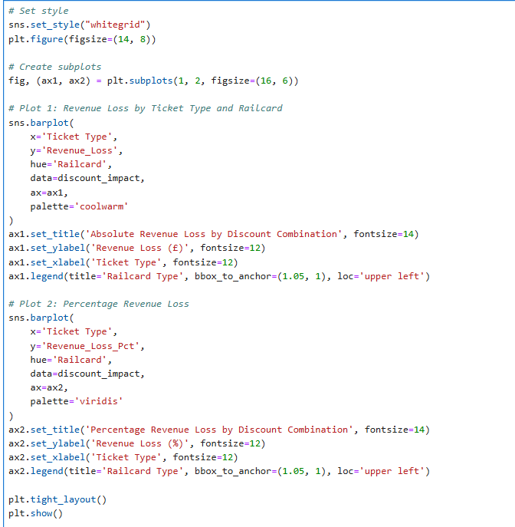

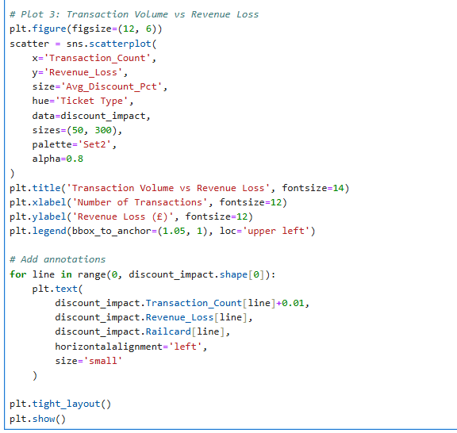

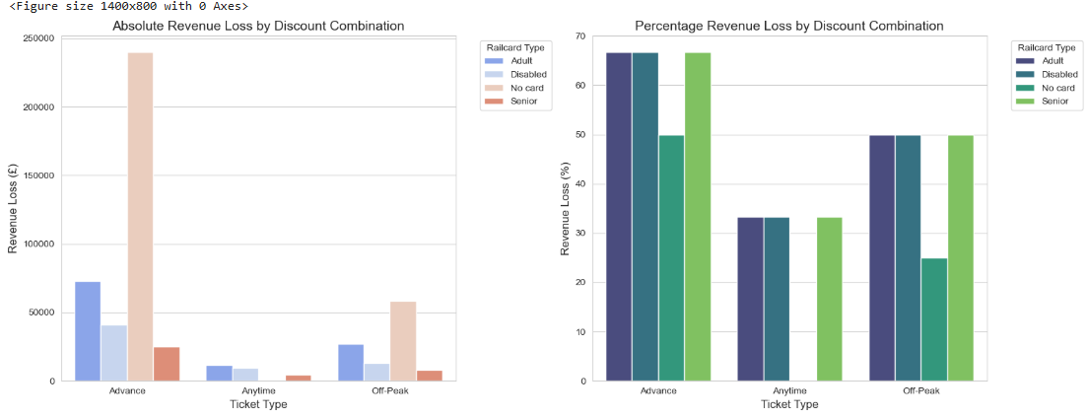

Step 19: Price Elasticity Analysis
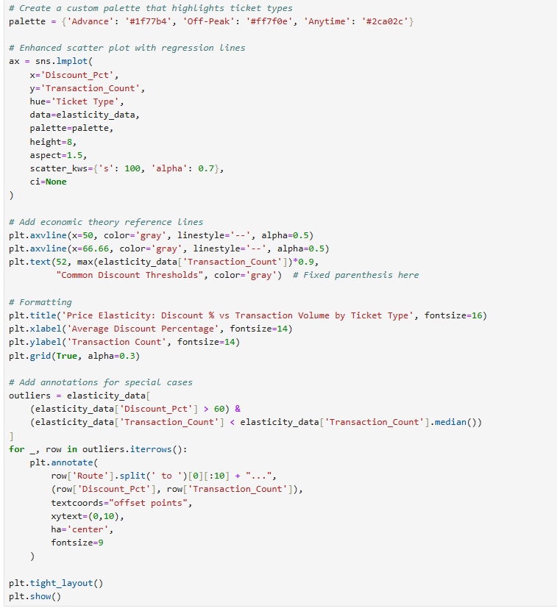

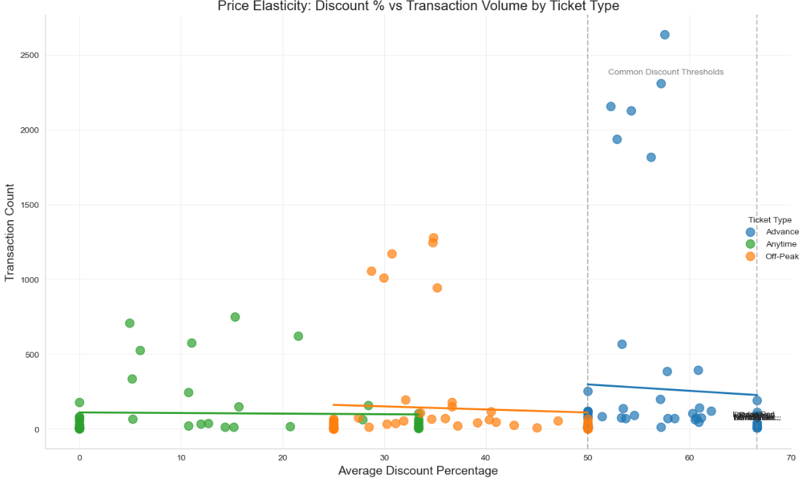

In this last visual the nearly horizontal lines of relationship between discount percentage and demand suggest that demand is nearly affected by the discount. That’s the concept of price elasticity.

Price Elasticity:
We utilized two statistical models to calculate price elasticity which we will use later for our predictions. First was the Ordinary Least Squares (OLS) and Generalized Linear Models (GLM).
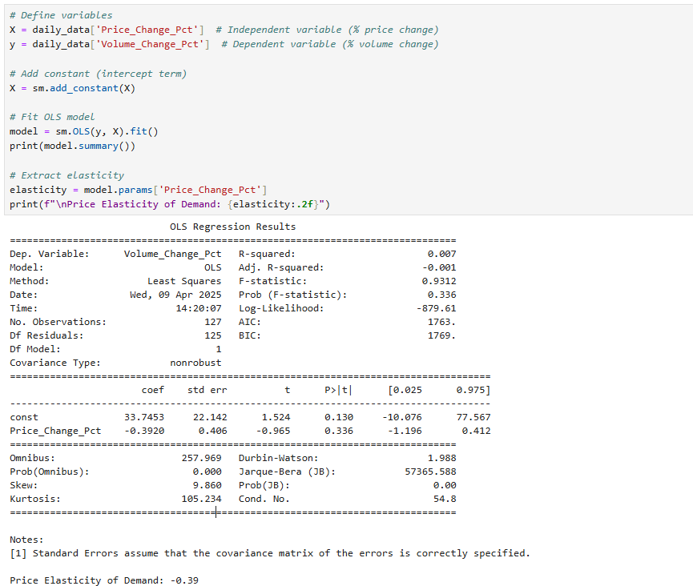
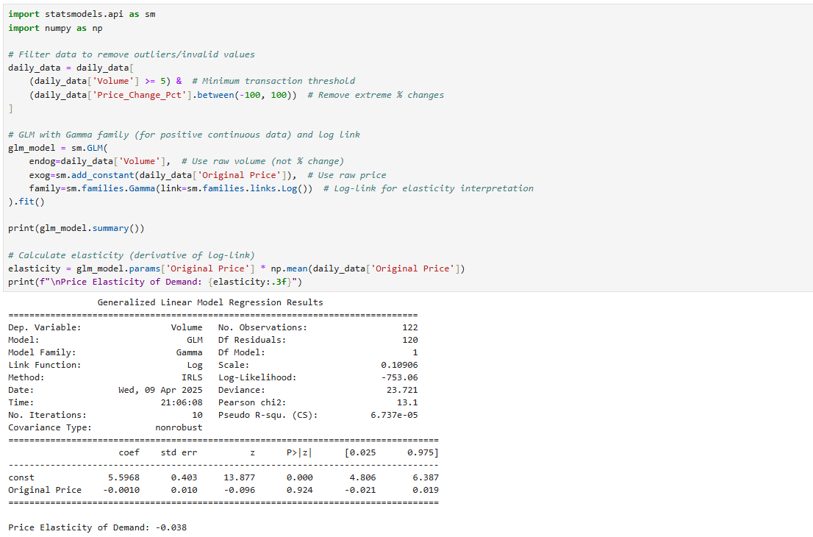

GLM (Gamma with Log Link)
- Model: Volume ~ Original Price
- Rationale: GLM with Gamma distribution is suitable for positive continuous outcomes (e.g., sales volume), and the log-link makes it interpretable in elasticity terms.
- Elasticity Estimate: -0.038
  - Interpretation: A 1% increase in price is associated with a 0.038% decrease in volume, on average.
- Statistical Significance:
  - The coefficient for Original Price is not statistically significant (p = 0.924).
- Pseudo R² (Cragg & Uhler's R²): Very low (6.7e-05), indicating the model explains very little variation in volume.
📉 Insight: Demand is highly inelastic with respect to price in this dataset—price has almost no impact on demand volume.

📊 OLS (Percentage Changes)
- Model: Volume_Change_Pct ~ Price_Change_Pct
- Elasticity Estimate: -0.39
  - Interpretation: A 1% increase in price is associated with a 0.39% decrease in volume, on average.
- Statistical Significance:
  - The price elasticity coefficient is not statistically significant (p = 0.336).
- R² = 0.007: The model explains less than 1% of the variation in volume change.
📉 Insight: The relationship between price changes and volume changes is weak and statistically insignificant—suggesting other factors are likely driving demand more than price.

The target was to make some alterations to discounts offered by Advance tickets which represent the most of the revenue loss caused by cards and ticket types. Price elasticity will be used to predict the revenue or loss caused by the suggested decrease in the discount percentage offered by this ticket type.

Chapter 4: Predictions Based of Alteration of Discount Percentage of Advance tickets
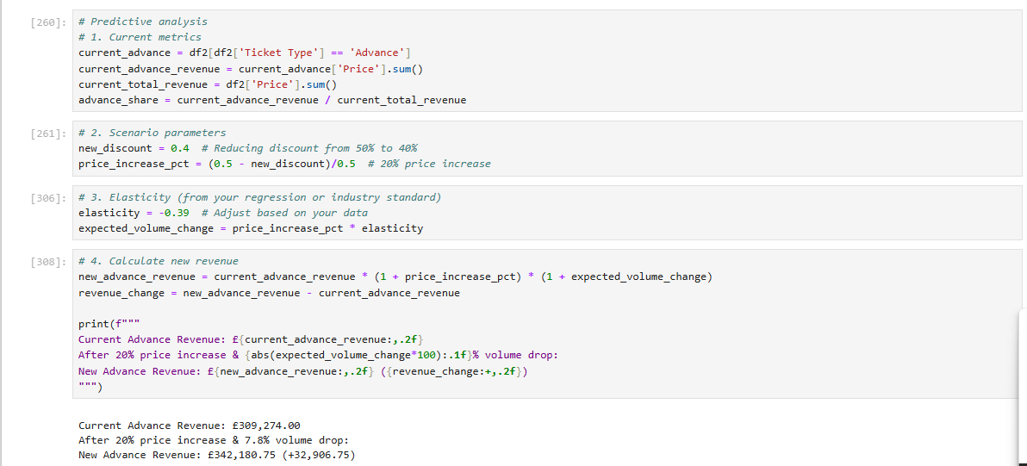

This script forecasts the revenue impact of changing discount policies for Advance tickets using price elasticity of demand. It follows 4 key steps:
- Current Baseline
  - Calculates existing Advance ticket revenue (£309,274)
  - Determines Advance tickets' share of total revenue
- Scenario Setup
  - Proposes reducing discounts from 50% → 40% (equivalent to 20% price increase)
  - price_increase_pct = (0.5 - 0.4)/0.5
- Demand Response
  - Applies elasticity (-0.39) to estimate volume change:
7.8% drop = 20% price increase × -0.39 elasticity

- Revenue Projection
  - New revenue = Price effect × Volume effect
£342,181 = £309,274 × 1.20 (price) × 0.922 (volume)

Key Outcomes
- Revenue Increase
  - +£32,907 (10.6% uplift) despite lower volume
  - Confirms Advance tickets are price inelastic (|ε| < 1)
- Tradeoffs
  - Gains come at the cost of 7.8% fewer customers
  - Potential long-term customer retention risks

Recommendation:
- Adjustments to the discount percentage of Advance tickets could be required to limit the revenue loss.
- The suggested decrease in discounts is 20% (from 50% to 40%).
- To limit the long-term customer attrition that could be caused by this change, we can:
    - Implement a dynamic discount system based on the time the ticket has been purchased. For example, 'Early’ (>15 days)': 45%, 'Standard’ (7-15 days)': 40%, 'Last Minute’ (1-7 days)': 35%.
    - Make the old discount as previously was only in off-peak trips.
    - Implement bundle pricing, “Buy more tickets, get higher discount”
    - Introduce loyalty programs upon which discount can be built. For example, 'Gold Program': 45%, 'Silver Program': 40%, 'Standard Program': 35%.
    - Start the new discount system in specific routes to assess customer satisfaction feedback.
    - Implement demand-based price adjustments, higher demand, higher prices.
    - Negotiate fixed discounts for bulk corporate purchases.

Chapter 5: Data Visualization Utilizing tableau

Dashboard 1: Overview
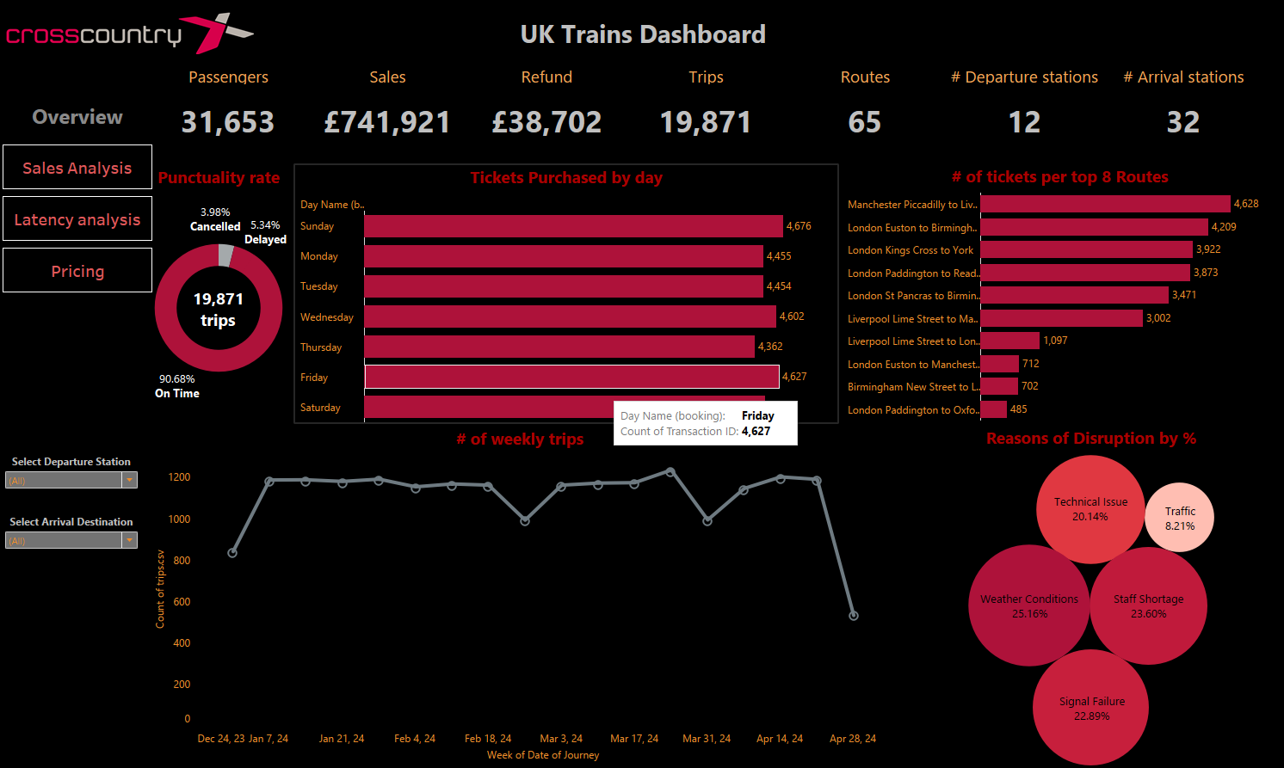

1. Overview and Purpose
This first dashboard provides a high-level summary of the key performance indicators (KPIs) for UK train operations over the selected period. It offers immediate insight into passenger volume, revenue performance, number of trips, routes served, and overall punctuality. By consolidating these data points, we can quickly gauge the health of the service network and identify areas needing further exploration.

2. Key Metrics and Highlights
- Passengers (31,653)
  - Reflects the total number of passengers carried during the reporting period.
  - A high passenger count can indicate strong demand on the network, but it also raises questions about capacity utilization and service quality.
- Sales (£741,921)
  - Represents the total revenue generated from ticket sales (excluding refunds).
  - Tracking revenue trends alongside passenger numbers can uncover shifts in travel patterns, fare pricing strategies, or promotional impacts.
- Refunds (£38,702)
  - Shows the amount reimbursed to passengers—often due to delays, cancellations, or other service disruptions.
  - A higher refund figure can signal significant punctuality or reliability issues on certain routes.
- Trips (19,871)
  - Denotes the total number of completed journeys.
  - Comparing trips with passenger count can inform load factor (average passengers per trip) and operational efficiency.
- Number of Routes (65)
  - Captures the breadth of network coverage.
  - Monitoring route count changes helps identify network expansion or consolidation over time.
- Departure Stations (12) and Arrival Stations
  - Highlights the spread of key stations served.
  - Useful for understanding how passenger flows are distributed across the network.
- Punctuality Rate
  - Shows the percentage of trains arriving on time. In the example, a figure around 90.63% is indicated, suggesting relatively robust performance but still leaving room for improvement.
  - Maintaining or improving punctuality is crucial for overall customer satisfaction.

3. Tickets Purchased by Day
- The bar chart (or breakdown) illustrates how tickets are purchased across weekdays (e.g., Monday, Tuesday, etc.).
- This data can reveal peak travel days—often midweek for business travel and weekends for leisure.
- Operators can use this information to allocate rolling stock and staffing more effectively, aligning resources with demand spikes.

4. Top 8 Routes by Tickets Sold
- The top eight routes are showcased with their respective ticket counts, highlighting the busiest corridors in the network.
- Understanding which routes dominate ticket sales is essential for targeted marketing, capacity planning, and prioritizing improvements.

5. Weekly Trips Trend
- A line chart displays fluctuations in weekly trip volumes over the reporting weeks (e.g., from early April to early May).
- Spikes or dips in this line might coincide with external factors such as holidays, special events, or seasonal patterns.

6. Reasons for Disruption (%)
- The donut or pie chart segments disruptions by cause (e.g., Technical Issues, Traffic, Weather Conditions, Staff Shortage, Signal Failure).
- Knowing the primary sources of delay helps prioritize operational improvements—whether that’s investing in infrastructure, revising timetables, or enhancing staff availability.

7. Actionable Insights
- Target Peak Demand:
  - The daily ticket purchase pattern suggests clear peaks (e.g., midweek vs. weekend). Adjusting seat availability and staff scheduling can improve service quality and reduce crowding.
- Focus on Busiest Routes:
  - The top 8 routes carry a significant portion of total passengers and thus warrant close monitoring for performance, on-board amenities, and reliability improvements.
- Minimize Refunds:
  - A notable amount of refunds indicates potential service reliability issues or customer dissatisfaction. Investigating root causes—particularly on routes with higher refunds—can enhance both customer satisfaction and revenue retention.
- Address Disruptions:
  - The breakdown of disruption types reveals where infrastructure or operational weaknesses exist. If technical issues or signal failures lead the chart, investing in upgrades or preventive maintenance could yield significant improvements in punctuality.

8. Recommendations and Next Steps
- Correlate Operational and Financial Data:
  - Compare revenue and refunds on each of the top 8 routes to determine if specific corridors are underperforming financially due to service interruptions.
- Investigate Seasonal Patterns:
  - Use the weekly trip trend and day-of-week ticket sales to plan for anticipated surges, e.g., holiday periods or popular travel days, to optimize rolling stock assignment.
- Enhance Reporting Depth:
  - Integrate additional metrics (e.g., average delay minutes, customer satisfaction scores) to gain a more complete perspective on performance and passenger experience.
- Continuous Monitoring:
  - Regularly update the dashboard to track improvements after interventions (e.g., new staff hires, upgraded signal systems). This ensures that performance initiatives remain data-driven and impactful.

Summary
This initial dashboard serves as a concise but powerful snapshot of overall network activity and health. By examining passenger numbers, revenue, punctuality, and disruption causes, operators can make informed decisions about operational priorities, resource allocation, and improvement strategies. As the starting point of the analysis report, this overview provides the context and foundation for deeper dives into specific aspects of the railway network in subsequent dashboards.

Dashboard 2: Sales and Passengers Analysis
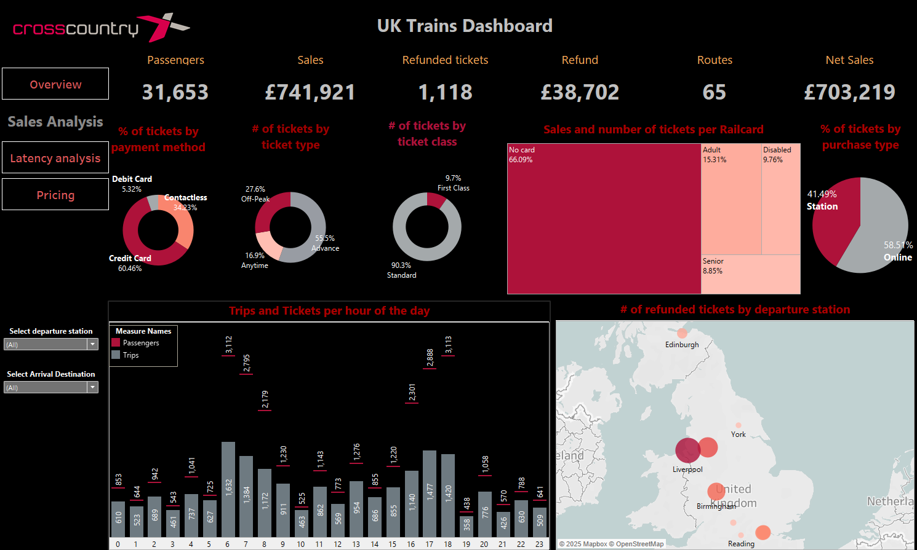

Key Performance Indicators
The CrossCountry UK Trains Dashboard reveals critical operational and financial metrics for the rail service:
- Passenger Volume: 31,653 passengers served across 65 routes
- Revenue Performance: £741,921 in total sales with £38,702 in refunds, yielding £703,219 in net sales
- Refund Rate: 1,118 refunded tickets, representing approximately 3.5% of total ticket volume
Customer Payment Behaviors
The payment method analysis indicates a strong preference for card payments:
- Credit card transactions dominate at 60.46%
- Contactless payments account for 29.23%
- Traditional debit card usage represents just 5.32%
Ticket Purchasing Patterns
Several notable purchasing patterns emerge:
- 55.9% of tickets are purchased in advance, while 27.6% are off-peak purchases
- Only 16.9% of tickets are bought for anytime travel, suggesting price sensitivity
- Online purchases (58.57%) outpace station purchases (41.49%)
- Standard class tickets (90.3%) significantly outnumber first class (9.7%)
Railcard Usage
The dashboard highlights that 66.09% of passengers travel without any railcard, while the remaining 33.91% utilize various railcard types:
- Adult railcards: 15.31%
- Disabled railcards: 9.76%
- Senior railcards: 8.85%
Temporal Analysis
The hourly distribution of trips and tickets shows:
- Distinct morning and evening peak travel periods
- Highest passenger volumes occurring around 07:00-09:00 and 16:00-18:00
- Several pronounced spikes in passenger numbers that exceed the number of trips, indicating higher occupancy during these periods
Refund Distribution
The geographic visualization reveals refund concentrations at specific departure stations:
- Major refund activity appears concentrated around York, Liverpool, and Birmingham
- Additional refund hotspots visible near Reading and scattered locations across the network
- On a closer look at Edinburgh station, there were 51 tickets bought at this station, all of them were refunded.

Dashboard 3: Latency and Cancellations Analysis
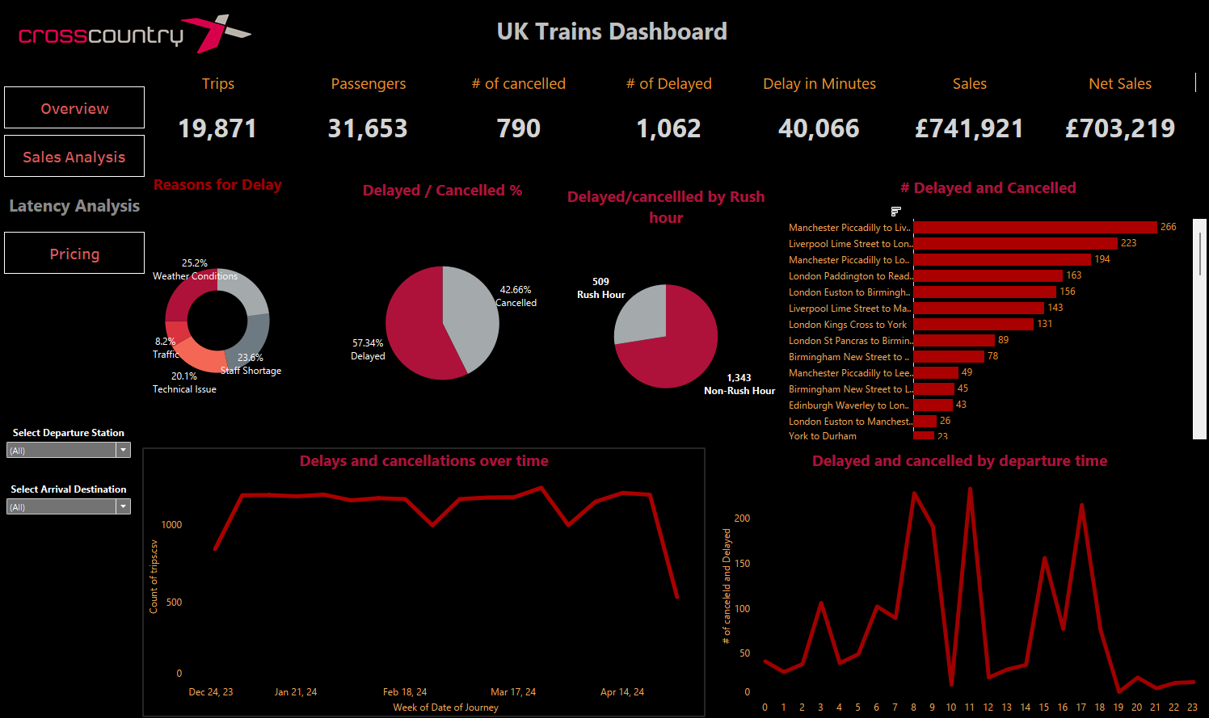

Executive Summary
This report provides a comprehensive analysis of latency and cancellations in the UK railroad network, focusing on key disruptions by time, reason, and route. The dashboard highlights critical insights into daily disruptions, peak times, root causes, and the most affected routes. Understanding these patterns is essential for improving operational efficiency, enhancing passenger experience, and mitigating future disruptions.

1. Overview of Latency and Cancellations
- Total Trips: 19,871
- Passengers Carried: 31,653
- Cancelled Trips: 790 (4.26% of total trips)
- Delayed Trips: 1,062 (5.73% of total trips)
- Total Delay Time: 40,066 minutes
- Sales Revenue: £741,921
- Net Sales: £703,219
The data indicates that while the majority of trips were completed successfully, a significant portion experienced delays or cancellations, impacting both operational performance and passenger satisfaction.

2. Peak Disruptions by Time of Day
The dashboard reveals distinct peaks in disruptions at specific times of the day, primarily during rush hours. Below are the key findings:
- 8:00 AM:
  - Primary Cause:72% due to Weather problems
  - Insight: Early morning operations are heavily influenced by adverse weather conditions, which can lead to widespread disruptions.
- 9:00 AM:
  - Primary Cause: 61% due to Signal failure
  - Insight: Signal issues during the morning rush hour highlight systemic challenges in maintaining infrastructure reliability.
- 11:00 AM:
  - Primary Cause: 55% due to Technical issues
  - Insight: Mid-morning disruptions are driven by technical malfunctions, indicating potential maintenance gaps or equipment failures.
- 3:00 PM:
  - Primary Cause: 69.9% due to Staff shortage
  - Insight: Afternoon disruptions are significantly impacted by staffing不足, suggesting resource allocation challenges during peak travel times.
- 5:00 PM:
  - Primary Cause: More than 59% due to Technical issues
  - Insight: Evening disruptions mirror mid-morning trends, with technical issues continuing to be a major concern.
Key Observation: Rush hour disruptions (8:00 AM, 9:00 AM, 3:00 PM, and 5:00 PM) are predominantly caused by external factors (weather conditions) or internal issues (technical problems, staff shortages, signal failure). Addressing these root causes is crucial for improving service reliability during peak periods.

3. Reasons for Delays and Cancellations
The donut chart in the dashboard breaks down the primary reasons for delays and cancellations:
- Weather Conditions: 25.2%
  - Impact: Adverse weather significantly affects train operations, particularly during early morning hours.
- Traffic: 8.2%
  - Impact: Traffic congestion near railway lines can delay trains, though it is a minor contributor compared to other factors.
- Staff Shortage: 20.1%
  - Impact: Staffing is a critical issue, especially during afternoon rush hours, highlighting the need for better workforce planning.
- Technical Issues: 20.1%
  - Impact: Technical malfunctions are the leading cause of disruptions, affecting multiple time periods throughout the day.
  - Signal Failure: 22.9%
  - Impact: Signal failure is a specific type of technical issues, the peak was around 9am which requires investigations to understand which it is repeated daily around this time.
Recommendation: Prioritize investments in weather-resistant infrastructure, signal system upgrades, and proactive maintenance schedules to mitigate technical issues. Additionally, optimize staffing levels to ensure adequate coverage during peak hours.

4. Disrupted Routes Analysis
The bar chart identifies the highest disrupted routes, providing insights into areas requiring targeted intervention:
- Manchester Piccadilly to Liverpool Lime Street:
  - Disruptions: 266
  - Insight: This route experiences the highest number of disruptions, likely due to its high demand and potential infrastructure challenges.
  - From these disruptions, 90 were due to staffing problems at 11am.
- Liverpool Lime Street to London Euston:
  - Disruptions: 223
  - Insight: As a long-distance route, this line may face additional logistical and environmental challenges.
  - From these disruptions, 75 were due to technical issues at 5pm.
- Manchester Piccadilly to London Euston:
  - Disruptions: 194
  - Insight: Similar to the above routes, this connection is critical but prone to frequent disruptions.
  - From these disruptions, 11o were due to weather extremes at 3am and 8am.
Key Observation: High-demand routes between major cities are disproportionately affected by disruptions. Enhancing infrastructure resilience and optimizing resource allocation along these routes should be a priority.

- 100% Disrupted Routes Analysis
In addition to the broader trends of disruptions, the dashboard highlights specific routes where all trips were disrupted during the analyzed period. These 100% disruption scenarios represent critical operational failures and warrant immediate attention. Below is a detailed breakdown of these routes:

a. York to Wakefield
- Total Trips: 15
- Disruption Cause: Staff shortage
- Insight: The complete disruption of this route underscores significant workforce planning challenges. Ensuring adequate staffing levels, particularly for shorter regional routes, is essential to prevent such occurrences.

b. London Euston to York
- Total Trips: 16
- Disruption Cause: Signal failure
- Insight: This long-distance route was entirely disrupted due to signal failures, indicating vulnerabilities in the signaling infrastructure along this corridor. Upgrading and maintaining signaling systems should be prioritized to improve reliability.

c. Edinburgh to London Kings Cross
- Total Trips: 43
- Disruption Cause: Staff shortage
- Insight: As one of the busiest and longest routes in the network, the total disruption of all 43 trips highlights severe staffing issues. Addressing workforce allocation and contingency planning is critical to ensure the continuity of service on high-demand routes.

6. Temporal Patterns of Delays and Cancellations
The line graph illustrates the trend of delays and cancellations over time:
- General Trend: The number of disruptions fluctuates throughout the period, with noticeable spikes during certain weeks.
- Seasonal Impact: Weather-related disruptions may explain some of the variability, as seen in the early months of the year (December–February).
- Consistency: Despite fluctuations, the overall disruption rate remains relatively stable, indicating consistent operational challenges.
Recommendation: Implement predictive analytics to anticipate seasonal disruptions and proactively allocate resources to mitigate risks.

7. Disruptions by Rush Hour vs. Non-Rush Hour
The pie chart comparing disruptions during rush hour versus non-rush hour reveals:
- Rush Hour Disruptions: 509 (42.6% of total disruptions)
  - Insight: Rush hour disruptions are more frequent and severe, driven by higher demand and compounded by external and internal factors.
- Non-Rush Hour Disruptions: 1,143 (57.4% of total disruptions)
  - Insight: While non-rush hour disruptions are less frequent, they still account for a significant portion, often due to technical issues and staff shortages.
Key Observation: Rush hour disruptions are more intense but less frequent, whereas non-rush hour disruptions are more persistent. A balanced approach addressing both scenarios is necessary.

8. Recommendations
Based on the analysis, the following recommendations are proposed:
- Weather Mitigation Strategies:
  - Invest in weather-resistant infrastructure and real-time weather monitoring systems to minimize the impact of adverse conditions.
- Signal System Upgrades:
  - Upgrade signal systems to enhance reliability and reduce failure rates, particularly during morning rush hours.
- Proactive Maintenance:
  - Implement a robust maintenance schedule to address technical issues before they escalate into disruptions.
- Staffing Optimization:
  - Analyze staffing需求 during peak hours and implement flexible scheduling to ensure adequate coverage.
- Route-Specific Interventions:
  - Focus on high-disruption routes like Manchester Piccadilly to Liverpool Lime Street and Liverpool Lime Street to London Euston by improving infrastructure and increasing resource allocation.
- Predictive Analytics:
  - Use data-driven models to predict disruptions based on historical patterns and external factors, enabling proactive mitigation strategies.

In addition to these recommendations, to address 100% disrupted routes effectively:
- Workforce Planning:
  - Conduct a comprehensive review of staffing levels across all routes, with a focus on ensuring adequate coverage during peak periods and for high-demand routes.
  - Implement flexible staffing policies and cross-training programs to mitigate staff shortages.
- Signaling System Upgrades:
  - Prioritize investments in modern signaling technologies for critical routes like London Euston to York to reduce the risk of signal failures.
- Contingency Plans:
  - Develop robust contingency plans for routes prone to complete disruptions, including alternative transportation options or real-time communication with passengers.

Conclusion
The dashboard provides valuable insights into the latency and cancellations affecting UK Trains' operations. Key disruptions occur during rush hours, driven by weather conditions, signal failures, technical issues, and staff shortages. High-demand routes between major cities are disproportionately affected, necessitating targeted interventions. By addressing these root causes and implementing strategic improvements, CrossCountry can enhance operational efficiency, reduce disruptions, and improve passenger satisfaction.
Final Recommendation: Develop an integrated action plan focusing on weather resilience, infrastructure upgrades, proactive maintenance, and optimized staffing to systematically address the identified challenges.

Dashboard 4: Pricing and Discounts Policy
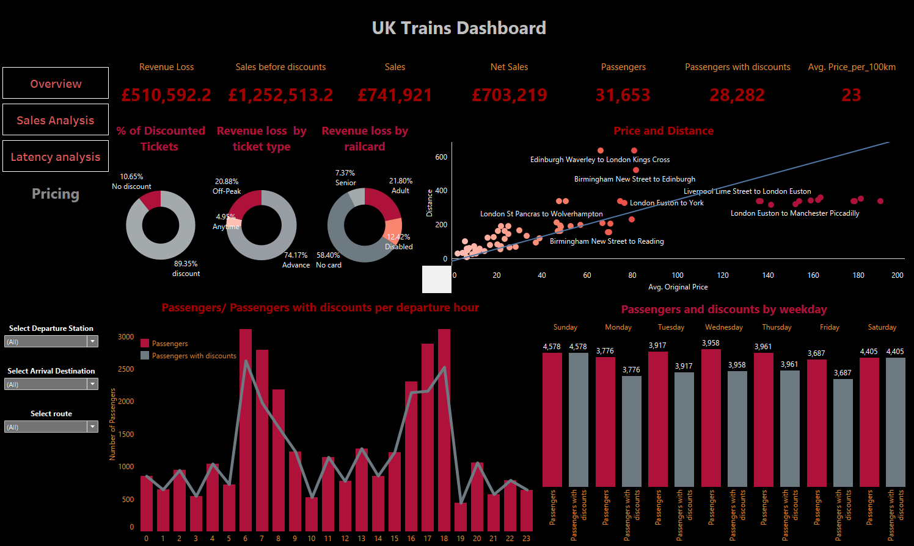

Executive Summary
This report focuses on the revenue analysis of UK Trains, highlighting the impact of discounts (based on ticket types and railcards) on sales and net revenue. The dashboard provides insights into passenger behavior, pricing strategies, and key drivers of revenue loss. Key findings include the significant role of discounts in reducing revenue, particularly for Advance tickets, and the importance of understanding passenger preferences by time of day, weekday, and route.

1. Overview of Revenue Metrics
The dashboard presents critical financial metrics related to sales and revenue:
- Revenue Loss: £510,592.2
  - This represents the total revenue lost due to discounts applied to tickets.
- Sales Before Discounts: £1,252,513.2
  - This is the total revenue generated before applying any discounts.
- Sales After Discounts (Net Sales): £703,219
  - This reflects the actual revenue retained after accounting for discounts.
- Passengers: 31,653
  - Total number of passengers who traveled during the analyzed period.
- Passengers with Discounts: 28,282
  - Number of passengers who availed discounts, representing approximately 89.35% of total passengers.
- Average Price per 100km: £23
  - Indicates the average fare charged per 100 kilometers traveled.

2. Key Insights from the Dashboard
2.1 Discount Usage Patterns
- Discounted Tickets (%):
  - No Discount: 10.65%, With discount 89.35%
    - Passengers traveling without any discounts are only during peak hours (6–8 AM and 4–6 PM) or weekdays.
- Revenue Loss by Ticket Type
  - Advance: 74.17%
    - The most popular discount type, accounting for the majority of discounted tickets.
  - Off-Peak: 20.88%
    - A significant portion of discounted tickets, reflecting off-peak travel patterns.
  - Anytime: 4.93%
    - Less common compared to Advance and Off-Peak tickets.
- Revenue Loss by Railcard type:
  - No card: 58.40%
    - The major driver of revenue loss, despite no railcard discount, This category shows high revenue loss because other discounts (e.g., Advance or Off-Peak) were used
    - Adult: 21.80%
    - Contributes significantly to revenue loss due to a 33.33% discount.
  - Disabled: 12.42%
    - Represents a smaller portion of revenue loss but highlights the impact of accessibility discounts.
  - Senior: 7.37%
    - Similar to Disabled, this category has a moderate impact on revenue loss.
2.2 Passenger Behavior by Time of Day
- Passengers/Passengers with Discounts per Departure Hour:
  - Peak Hours (6–8 AM and 4–6 PM):
    - Fewer passengers use discounts during these times, as indicated by the lower proportion of "Passengers with discounts" relative to total passengers.
  - Non-Peak Hours:
    - All passengers opt for discounted tickets.
2.3 Weekday Analysis
- Passengers and Discounts by Weekday:
  - Weekdays (Monday–Friday):
    - Higher overall passenger numbers and a consistent pattern of discount usage, reflecting commuting trends.
  - Weekends (Saturday and Sunday):
    - Lower passenger numbers but still significant discount usage, indicating leisure travel.
2.4 Price and Distance Relationship
- Price and Distance Scatter Plot:
  - General Trend: Price is proportionally related to distance, with a few outliers.
  - Outliers: Certain routes (e.g., Edinburgh Waverley to London Kings Cross) show lower prices than expected based on distance, likely due to demand or premium services. In addition, Manchester Piccadilly to London Kings cross route show higher prices than expected.

3. Major Drivers of Revenue Loss
- Advance Tickets:
  - Impact: Advance tickets account for 74.17% of revenue loss. The 50% discount on these tickets significantly impacts overall revenue.
  - Insight: While Advance tickets encourage early booking and improve capacity planning, their high discount rate poses a challenge to revenue optimization.
- Off-Peak Tickets:
  - Impact: Off-Peak tickets contribute 20.88% of revenue loss. The 25% discount on these tickets also contributes to reduced revenue.
  - Insight: Off-Peak tickets are effective in balancing demand across different times of the day but come at the cost of lower fares.
- Railcards:
  - Impact: Railcards (Adult, Senior, Disabled) collectively account for a significant portion of revenue loss, particularly for Adult railcards (21.80%).
  - Insight: Railcards promote accessibility and affordability but reduce revenue. Balancing inclusivity with financial sustainability is crucial.
- "No Card" Category:
  - Impact: Despite receiving no railcard discounts, the "No Card" category shows the highest revenue loss (12.2%). This is because passengers in this category often use other discounts (e.g., Advance or Off-Peak).
  - Insight: Understanding the overlap between different discount types is essential for optimizing revenue.

4. Recommendations
Based on the insights from the dashboard, the following recommendations are proposed to mitigate revenue loss while maintaining passenger satisfaction:
- Optimize Discount Structures:
  - Advance Tickets: Consider reducing the 50% discount for Advance tickets, especially for long-distance routes where demand is high.
  - Off-Peak Tickets: Maintain the 25% discount but explore dynamic pricing based on real-time demand.
- Enhance Railcard Pricing Strategy:
  - Review the 33.33% discount for railcards, particularly for Adult railcards, which contribute significantly to revenue loss.
  - Introduce tiered discounts based on usage frequency or travel volume to incentivize loyalty without excessive revenue loss.
- Target Peak Hour Pricing:
  - Leverage the fact that fewer passengers use discounts during peak hours (6–8 AM and 4–6 PM) by implementing dynamic pricing strategies. For example:
    - Offer small discounts for last-minute bookings during peak hours to fill the remaining capacity.
    - Increase peak-hour fares slightly to reflect higher demand.
- Analyze and Address Overlapping Discounts:
  - Investigate the "No Card" category further to understand why passengers are still experiencing significant revenue loss despite not using railcards. Focus on reducing overlapping discounts (e.g., combining Advance and Off-Peak discounts).
- Improve Pricing Transparency:
  - Ensure that passengers clearly understand the value proposition of different ticket types and railcards. Transparent communication can help manage expectations and reduce reliance on discounts.
- Monitor and Adjust Based on Route Performance:
  - Use the scatter plot of price vs. distance to identify routes with disproportionately high prices or discounts. Adjust pricing strategies accordingly to optimize revenue.

5. Next Steps
- Data Collection and Refinement:
  - Gather additional data on passenger demographics, travel purposes, and discount usage patterns to refine pricing strategies.
- Pilot Testing:
  - Implement pilot programs to test new pricing structures (e.g., reduced discounts for Advance tickets) on selected routes or during specific periods.
- Customer Feedback:
  - Collect feedback from passengers to understand their perceptions of new pricing strategies and make adjustments as needed.
- Regular Monitoring:
  - Continuously monitor revenue metrics, discount usage, and passenger behavior to ensure that changes are having the desired impact.

Conclusion
The dashboard provides valuable insights into the impact of discounts on revenue, highlighting the need for a balanced approach to pricing strategy. By optimizing discount structures, enhancing railcard pricing, and leveraging peak-hour opportunities, UK Trains can mitigate revenue loss while maintaining passenger satisfaction. Implementing these recommendations will require careful planning and ongoing evaluation to achieve sustainable financial performance.

Chapter 6: Executive Summary and Recommendations

I. Critical Disruption Insights
- Concentration of Disruptions:
  - Top 3 Routes (Manchester Piccadilly, Liverpool Lime Street, and London Euston) account for 38% of all disruptions.
  - Top 9 Routes represent ~78% of disruptions and include:
    - Manchester Piccadilly ↔ Liverpool Lime Street
- Install backup Signaling systems, make shifts adjustments to accommodate staff shortage
    - Liverpool Lime Street ↔ London Euston
- Pre-assess train condition before journey to avoid technical problems, prioritize weather-proofing infrastructure.
    - Manchester Piccadilly ↔ London Euston
- Prioritize weather-proofing infrastructure, pre-assess train condition before journey to avoid technical problems.
    - London Paddington ↔ Reading
- Install backup Signaling systems, make shifts adjustments to accommodate staff shortage
    - London Euston ↔ Birmingham New Street
- Install backup Signaling systems, make shifts adjustments to accommodate staff shortage, prioritize weather-proofing infrastructure.
6. Liverpool Lime Street ↔ Manchester Piccadilly
- Pre-assess train condition before journey to avoid technical problems, install backup Signaling systems.
- London Kings Cross ↔ York
- Install backup Signaling systems
- London St Pancras ↔ Birmingham New Street
- Install backup Signaling systems, make shifts adjustments to accommodate staff shortage
- Birmingham New Street ↔ Manchester Piccadilly
- Pre-assess train condition before journey to avoid technical problems (88.5% of disruptions).

II. Priority Actions and Strategic Recommendations
A. Immediate Operational Fixes
- Staffing Shortages (especially 100% shortages):
  - Emergency crew scheduling (Edinburgh–London, York–Wakefield)
  - Competitive shift incentives and flexible scheduling
  - Conduct urgent audits (e.g., Edinburgh Waverley Station)
  - Merge under-staffed services with adjacent ones as a temporary solution
  - Major routes affected: Manchester Piccadilly ↔ Liverpool Lime Street, London Paddington ↔ Reading, London Euston ↔ Birmingham New Street.
- Signal Failures (especially routes with 100% disruptions):
  - Urgent deployment of signal teams (e.g., London Euston–York)
  - Install temporary backup signaling systems
  - Initiate preemptive signal maintenance on major routes affected: Manchester Piccadilly ↔ Liverpool Lime Street, London Euston ↔ Birmingham New Street and London Kings Cross ↔ York.
- Manchester Piccadilly Staffing Crisis:
  - Deploy backup personnel immediately to fill 90 journeys with shortage.

B. Infrastructure & System Investments
- Weather-Resilient Infrastructure:
  - Prioritize NW corridors (Manchester/Liverpool)
  - Install real-time weather monitoring
- Signal System Modernization:
  - Upgrade for reliability, especially on Liverpool-Manchester-London Euston-Birmingham corridors.
  - Focus on morning rush hour performance
- Proactive Maintenance:
  - Adopt predictive maintenance schedules across all routes
  - Prioritize high-failure locations like Liverpool–London Euston.

C. Staffing Strategy Overhaul
- Cross-train employees for flexibility
- Tailor recruitment/retention plans for critical corridors

III. Revenue Optimization & Customer Experience
A. Discount and Ticketing Strategy
- Advance Ticket Discounts:
  - Reduce blanket 50% discount to dynamic model (e.g., Early 45%, Standard 40%, Last-Minute 35%)
  - Restrict discount stacking (e.g., Advance + Railcard = >50% losses)
- Railcards:
  - Re-evaluate 33% blanket discount, especially for Adult railcards
  - Implement tiered railcard rewards based on loyalty or volume
- Peak Pricing:
  - Introduce dynamic pricing during high-demand windows (6–8 AM, 4–6 PM)
  - Upsell “Anytime/No card” segment with zero loss potential
B. Capacity and Revenue Management
- Increase train capacity on high-revenue routes (e.g., London–York)
- Investigate low-revenue anomalies (e.g., Birmingham–Wolverhampton)
- Run promotions on moderately underperforming routes (e.g., York–Leeds, Manchester–Warrington)

📌 Conclusion
This analysis provided a holistic view of the UK railway system’s operational performance, customer behavior, and revenue dynamics, underpinned by a robust data engineering pipeline and analytical modeling.
Key insights reveal that although 90.7% of journeys were completed on time, the 9.3% disruption rate—primarily driven by weather, technical failures, and staffing shortages—poses a significant threat to service reliability and passenger satisfaction. Crucial stations such as Manchester Piccadilly and Liverpool Lime Street emerged as major disruption hubs, requiring urgent infrastructure and resource allocation reviews.
From a financial perspective, discount policies—particularly around Advance and Railcard usage—are responsible for substantial revenue leakage. While price elasticity analyses confirm that demand is inelastic, a reduction in Advance ticket discounts from 50% to 40% could yield a 10.6% increase in revenue, with manageable demand loss. These findings support the implementation of a dynamic discounting strategy to balance affordability with profitability.
Furthermore, granular route-level analysis revealed that just a few corridors account for a disproportionate share of delays, cancellations, and refund costs. This underscores the need for targeted operational interventions—ranging from preventive maintenance and staffing adjustments to demand-driven pricing models.
In sum, this project demonstrates the power of data-driven insights in optimizing railway operations, improving customer satisfaction, and enhancing revenue performance. By integrating predictive modeling with visual analytics, stakeholders are empowered to make informed, strategic decisions for sustainable transport planning.

